Policy Safeguarding Children
Author: Paul Shanks/Kevin Blakey
Date of Approval: 11 September 2019
Approved by: Trust Board
Review date: September 2020

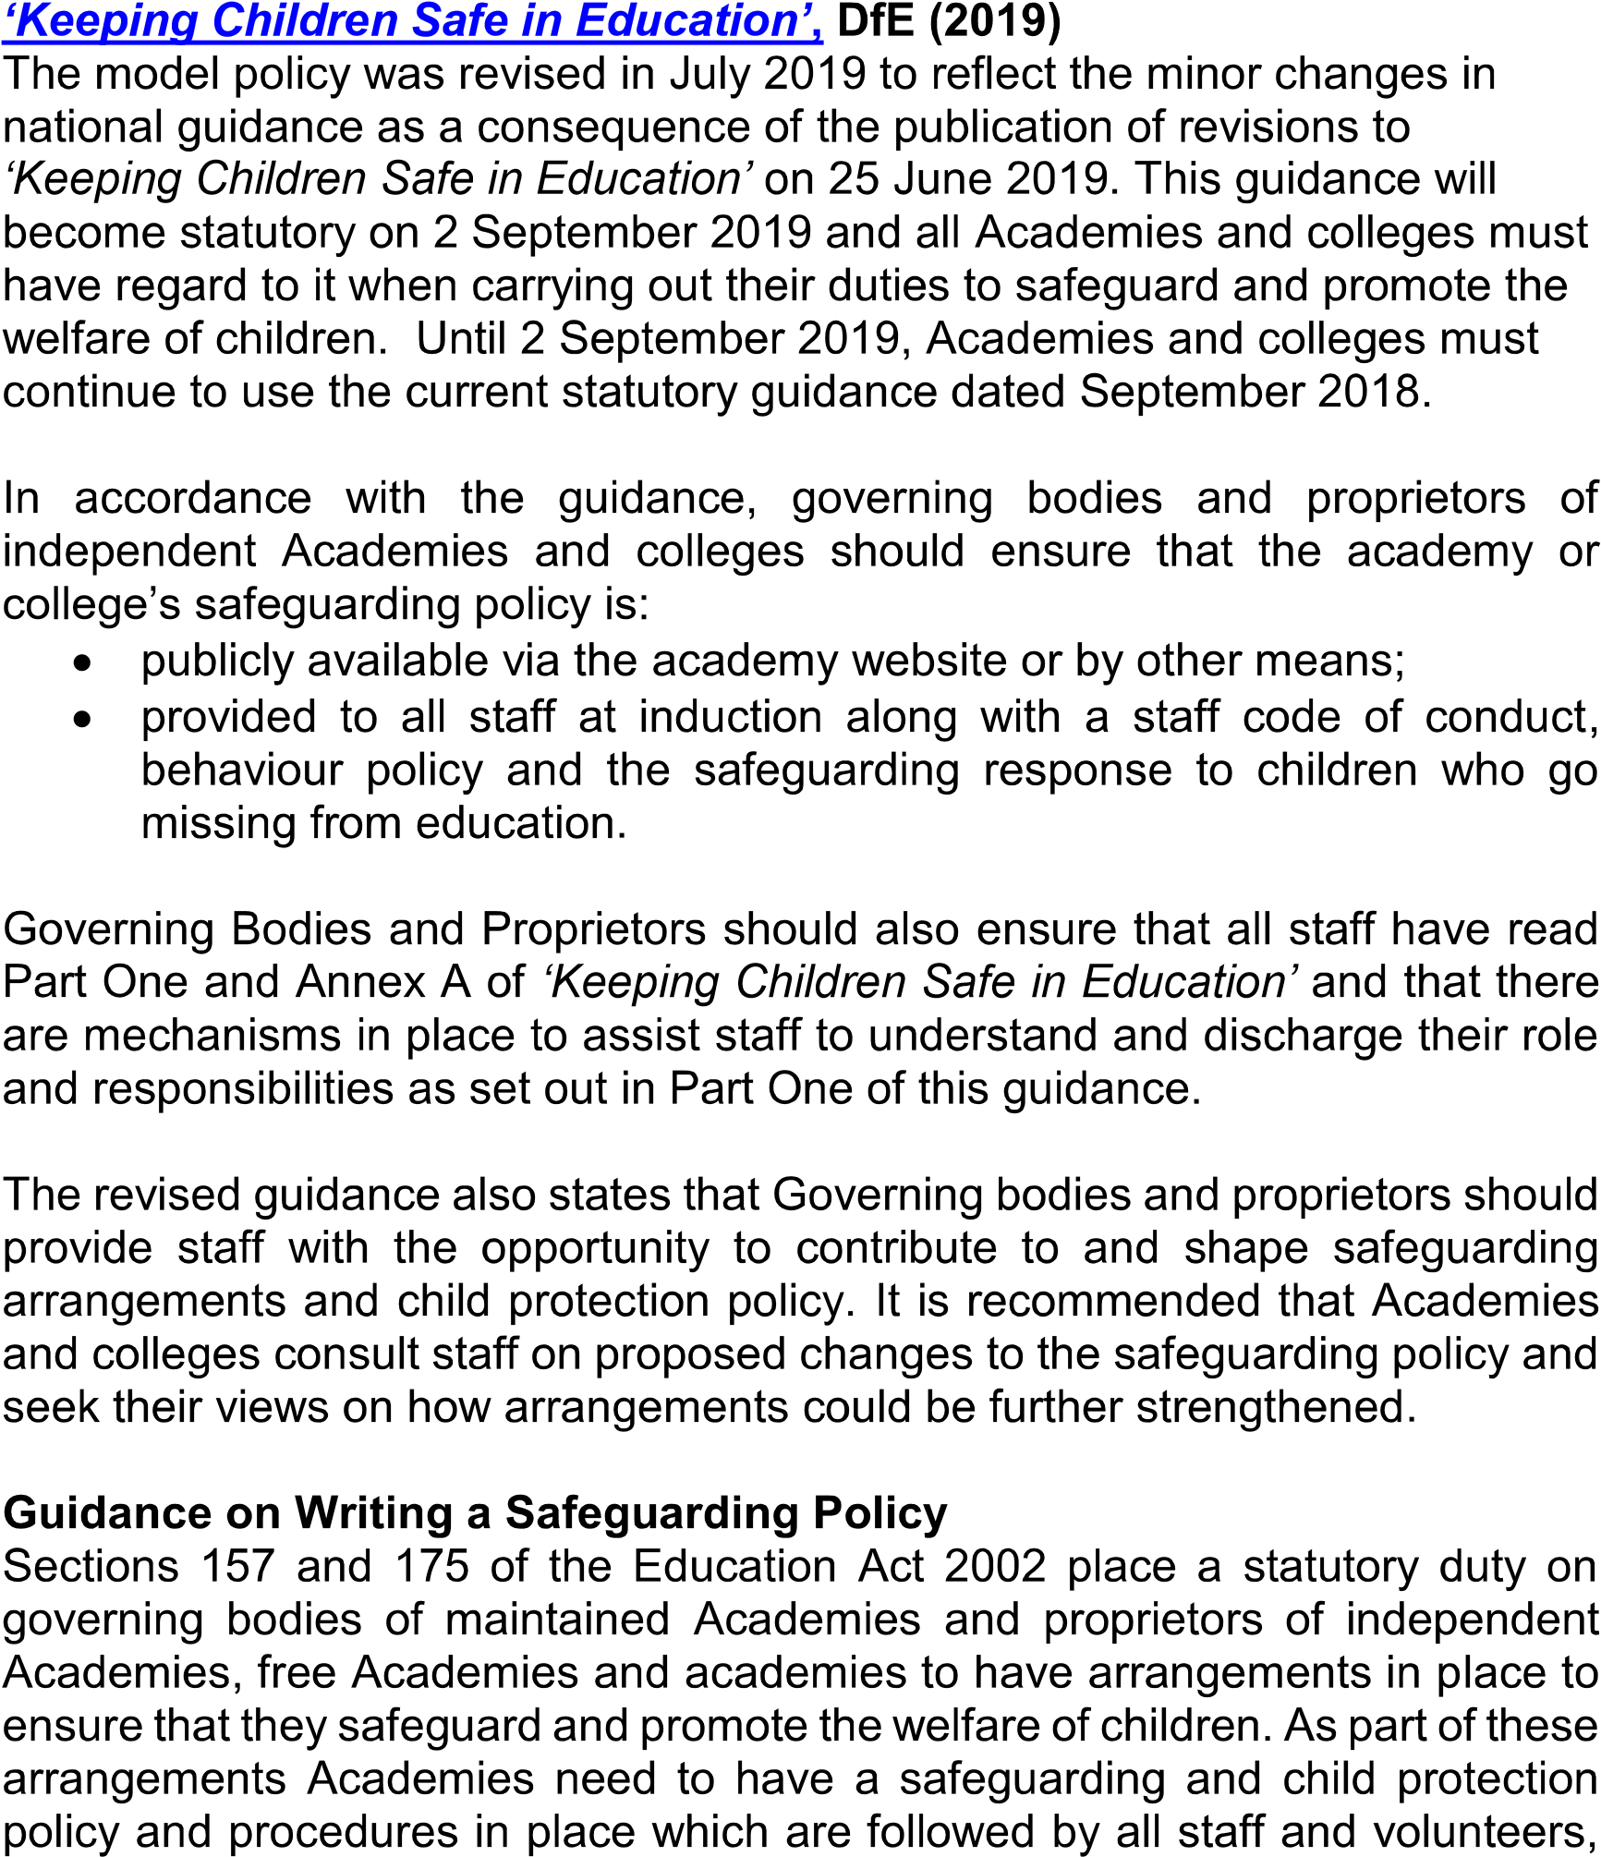
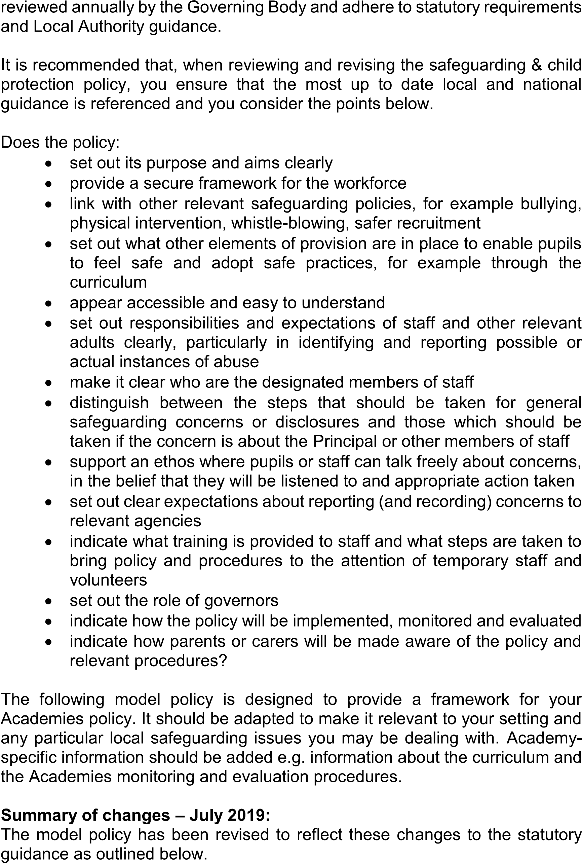
All references to ‘Keeping Children Safe in Education’
‘Keeping Children Safe in Education’ (201
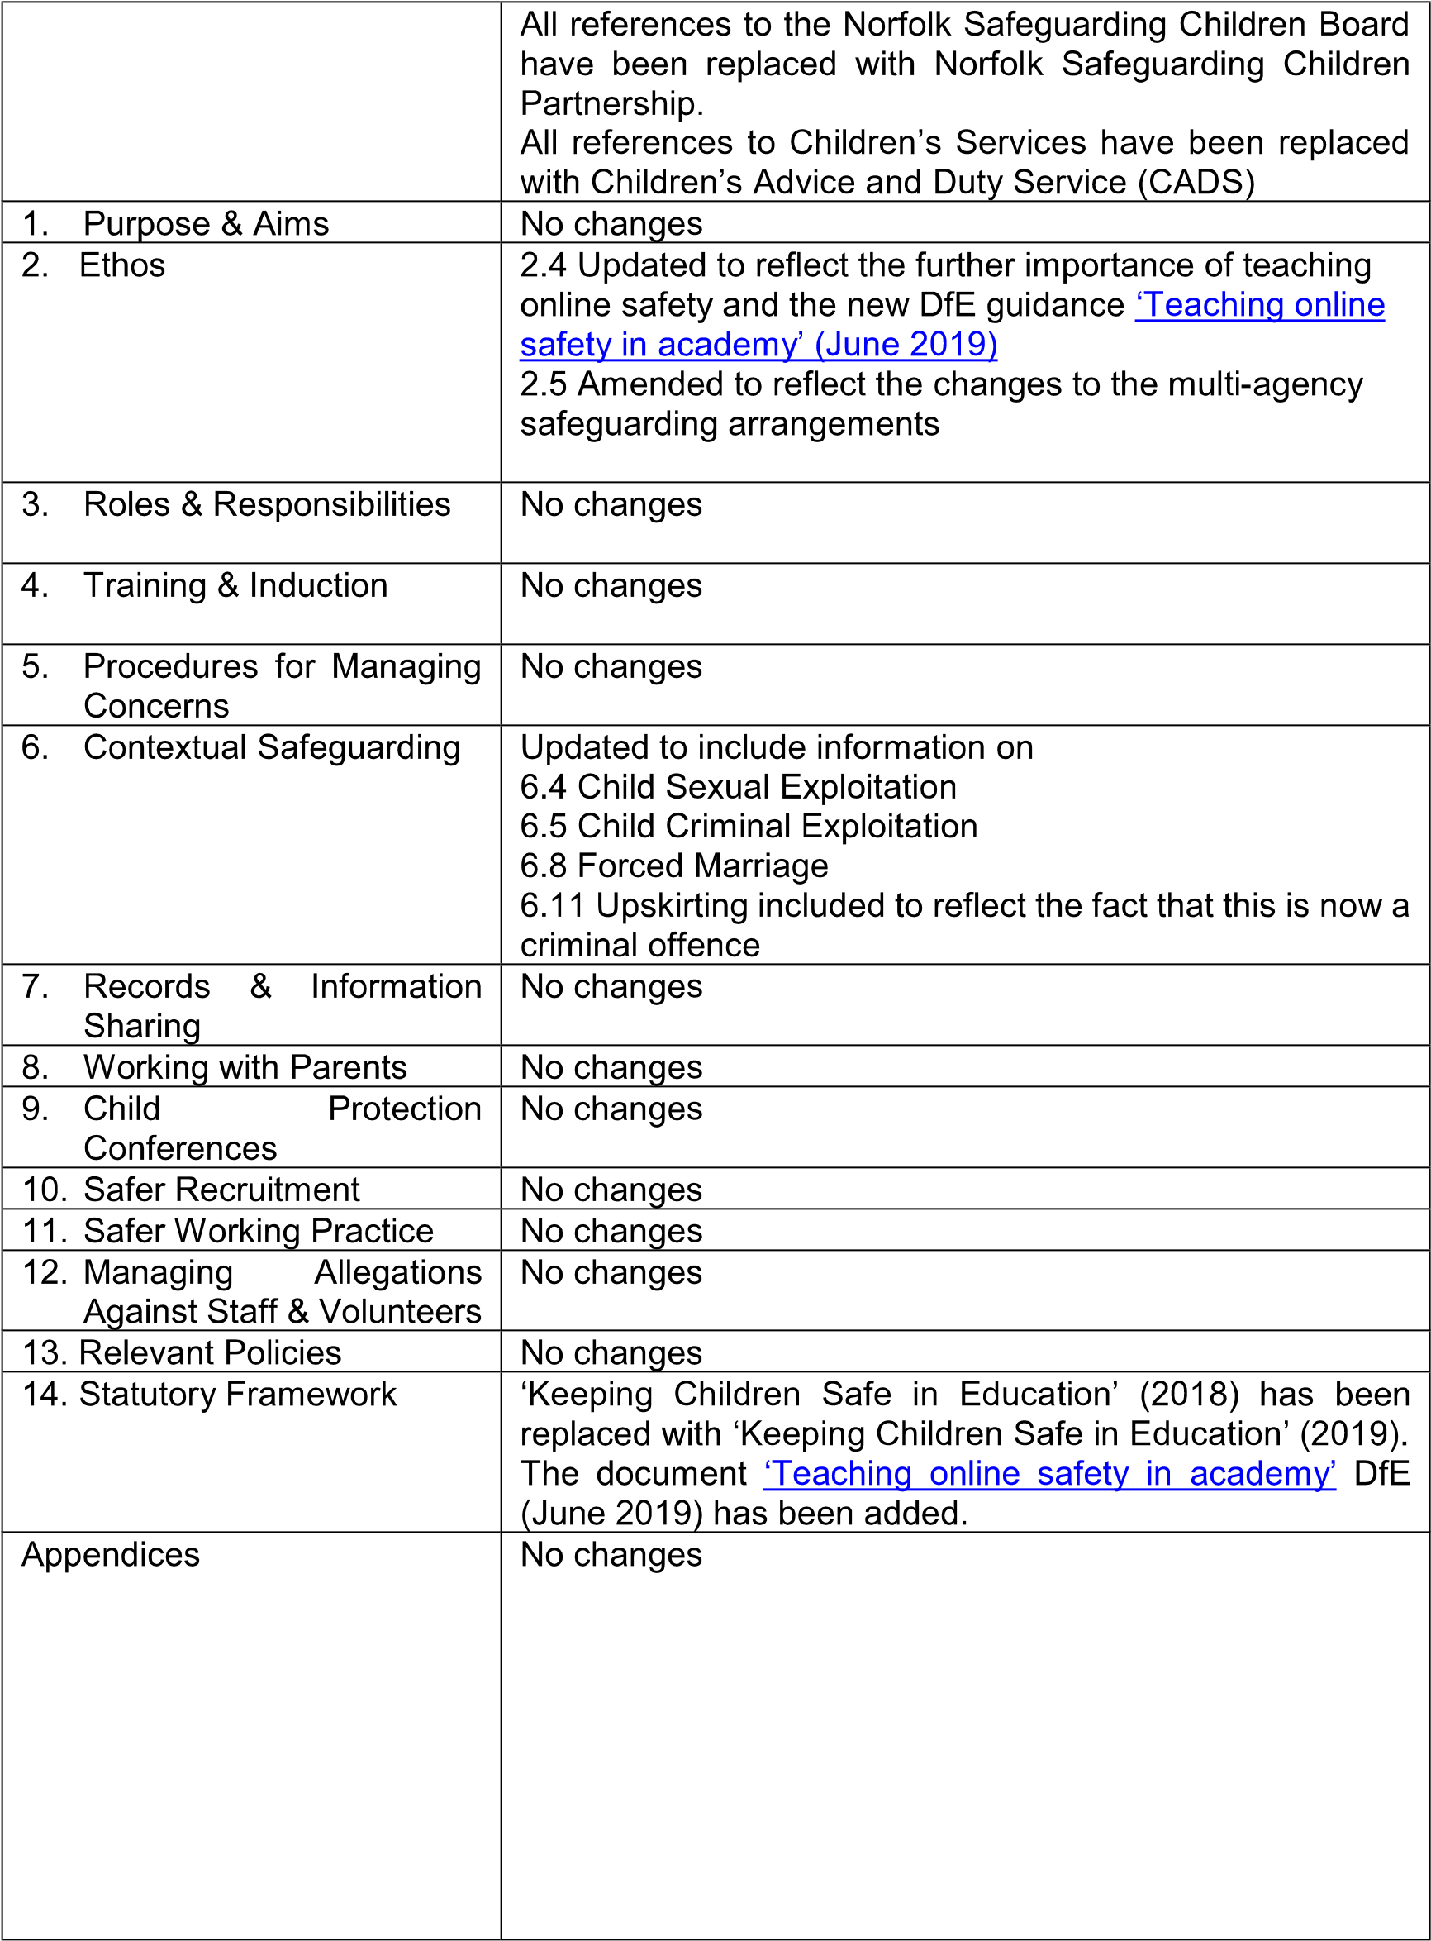
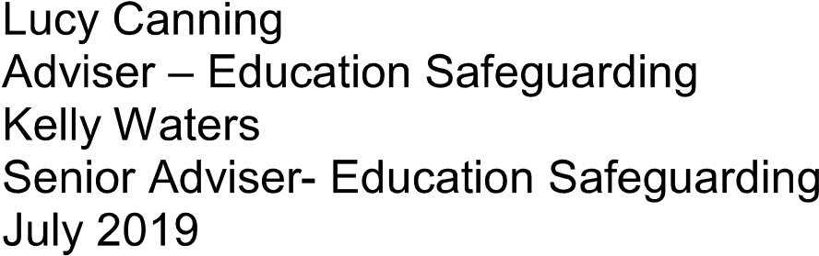
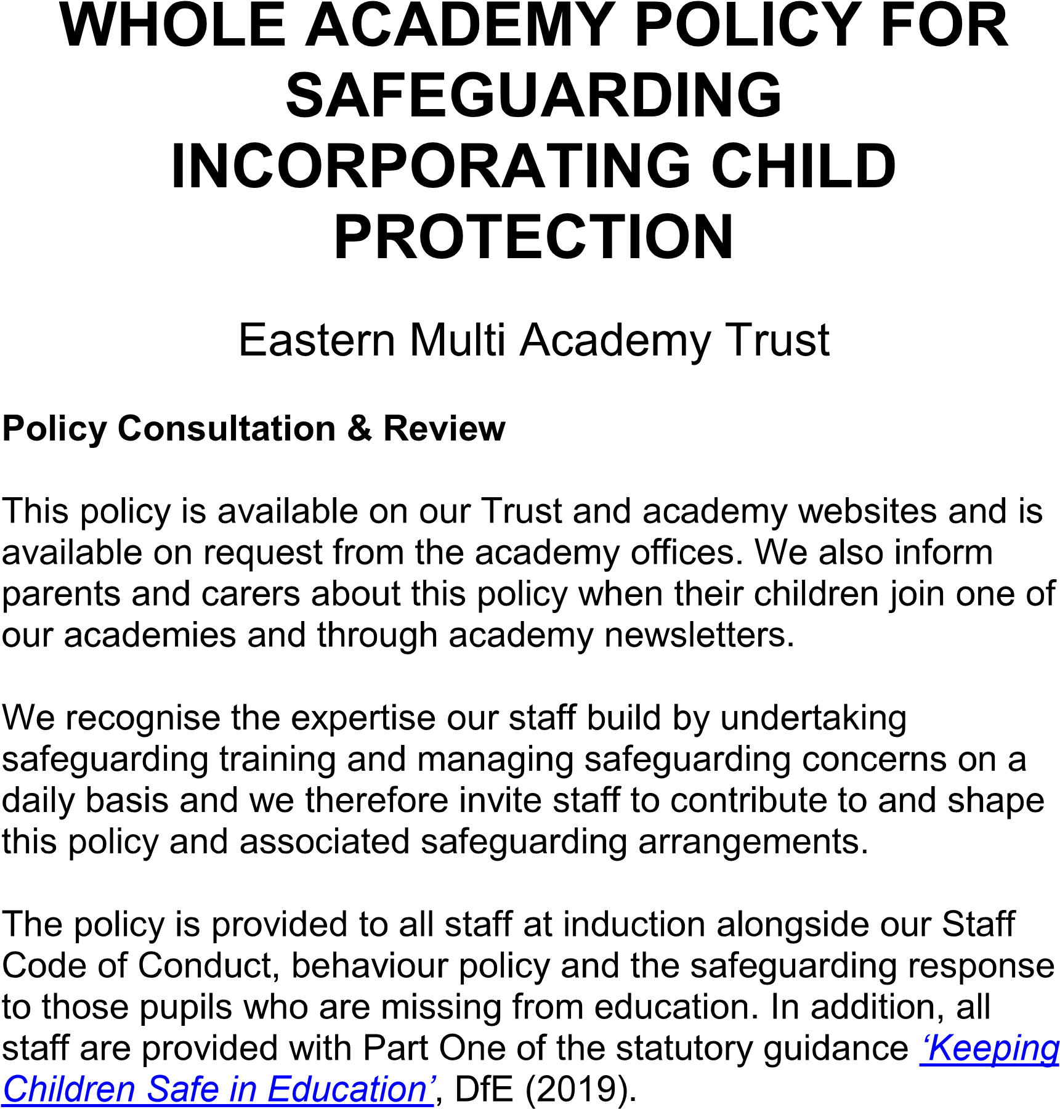
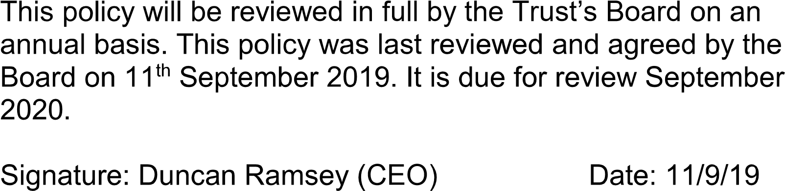

CONTENTS

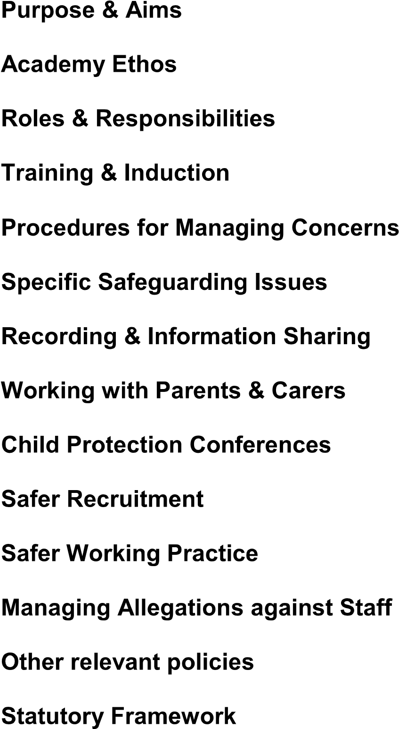
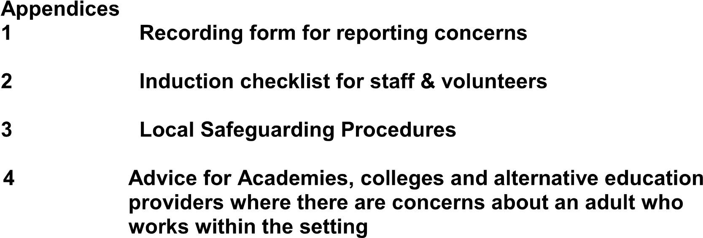

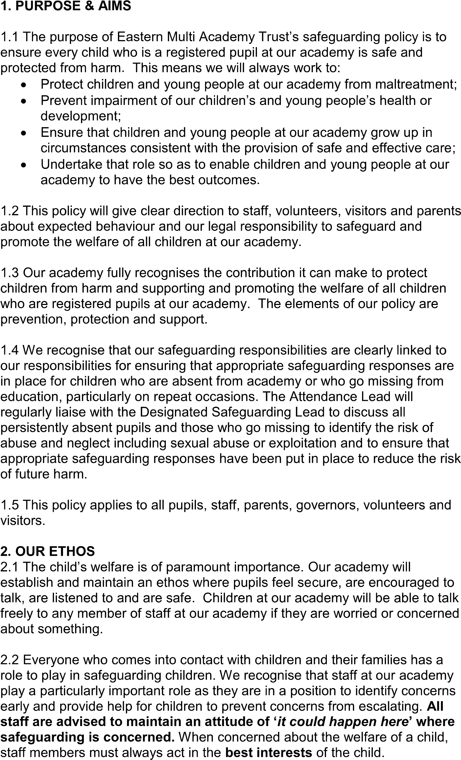
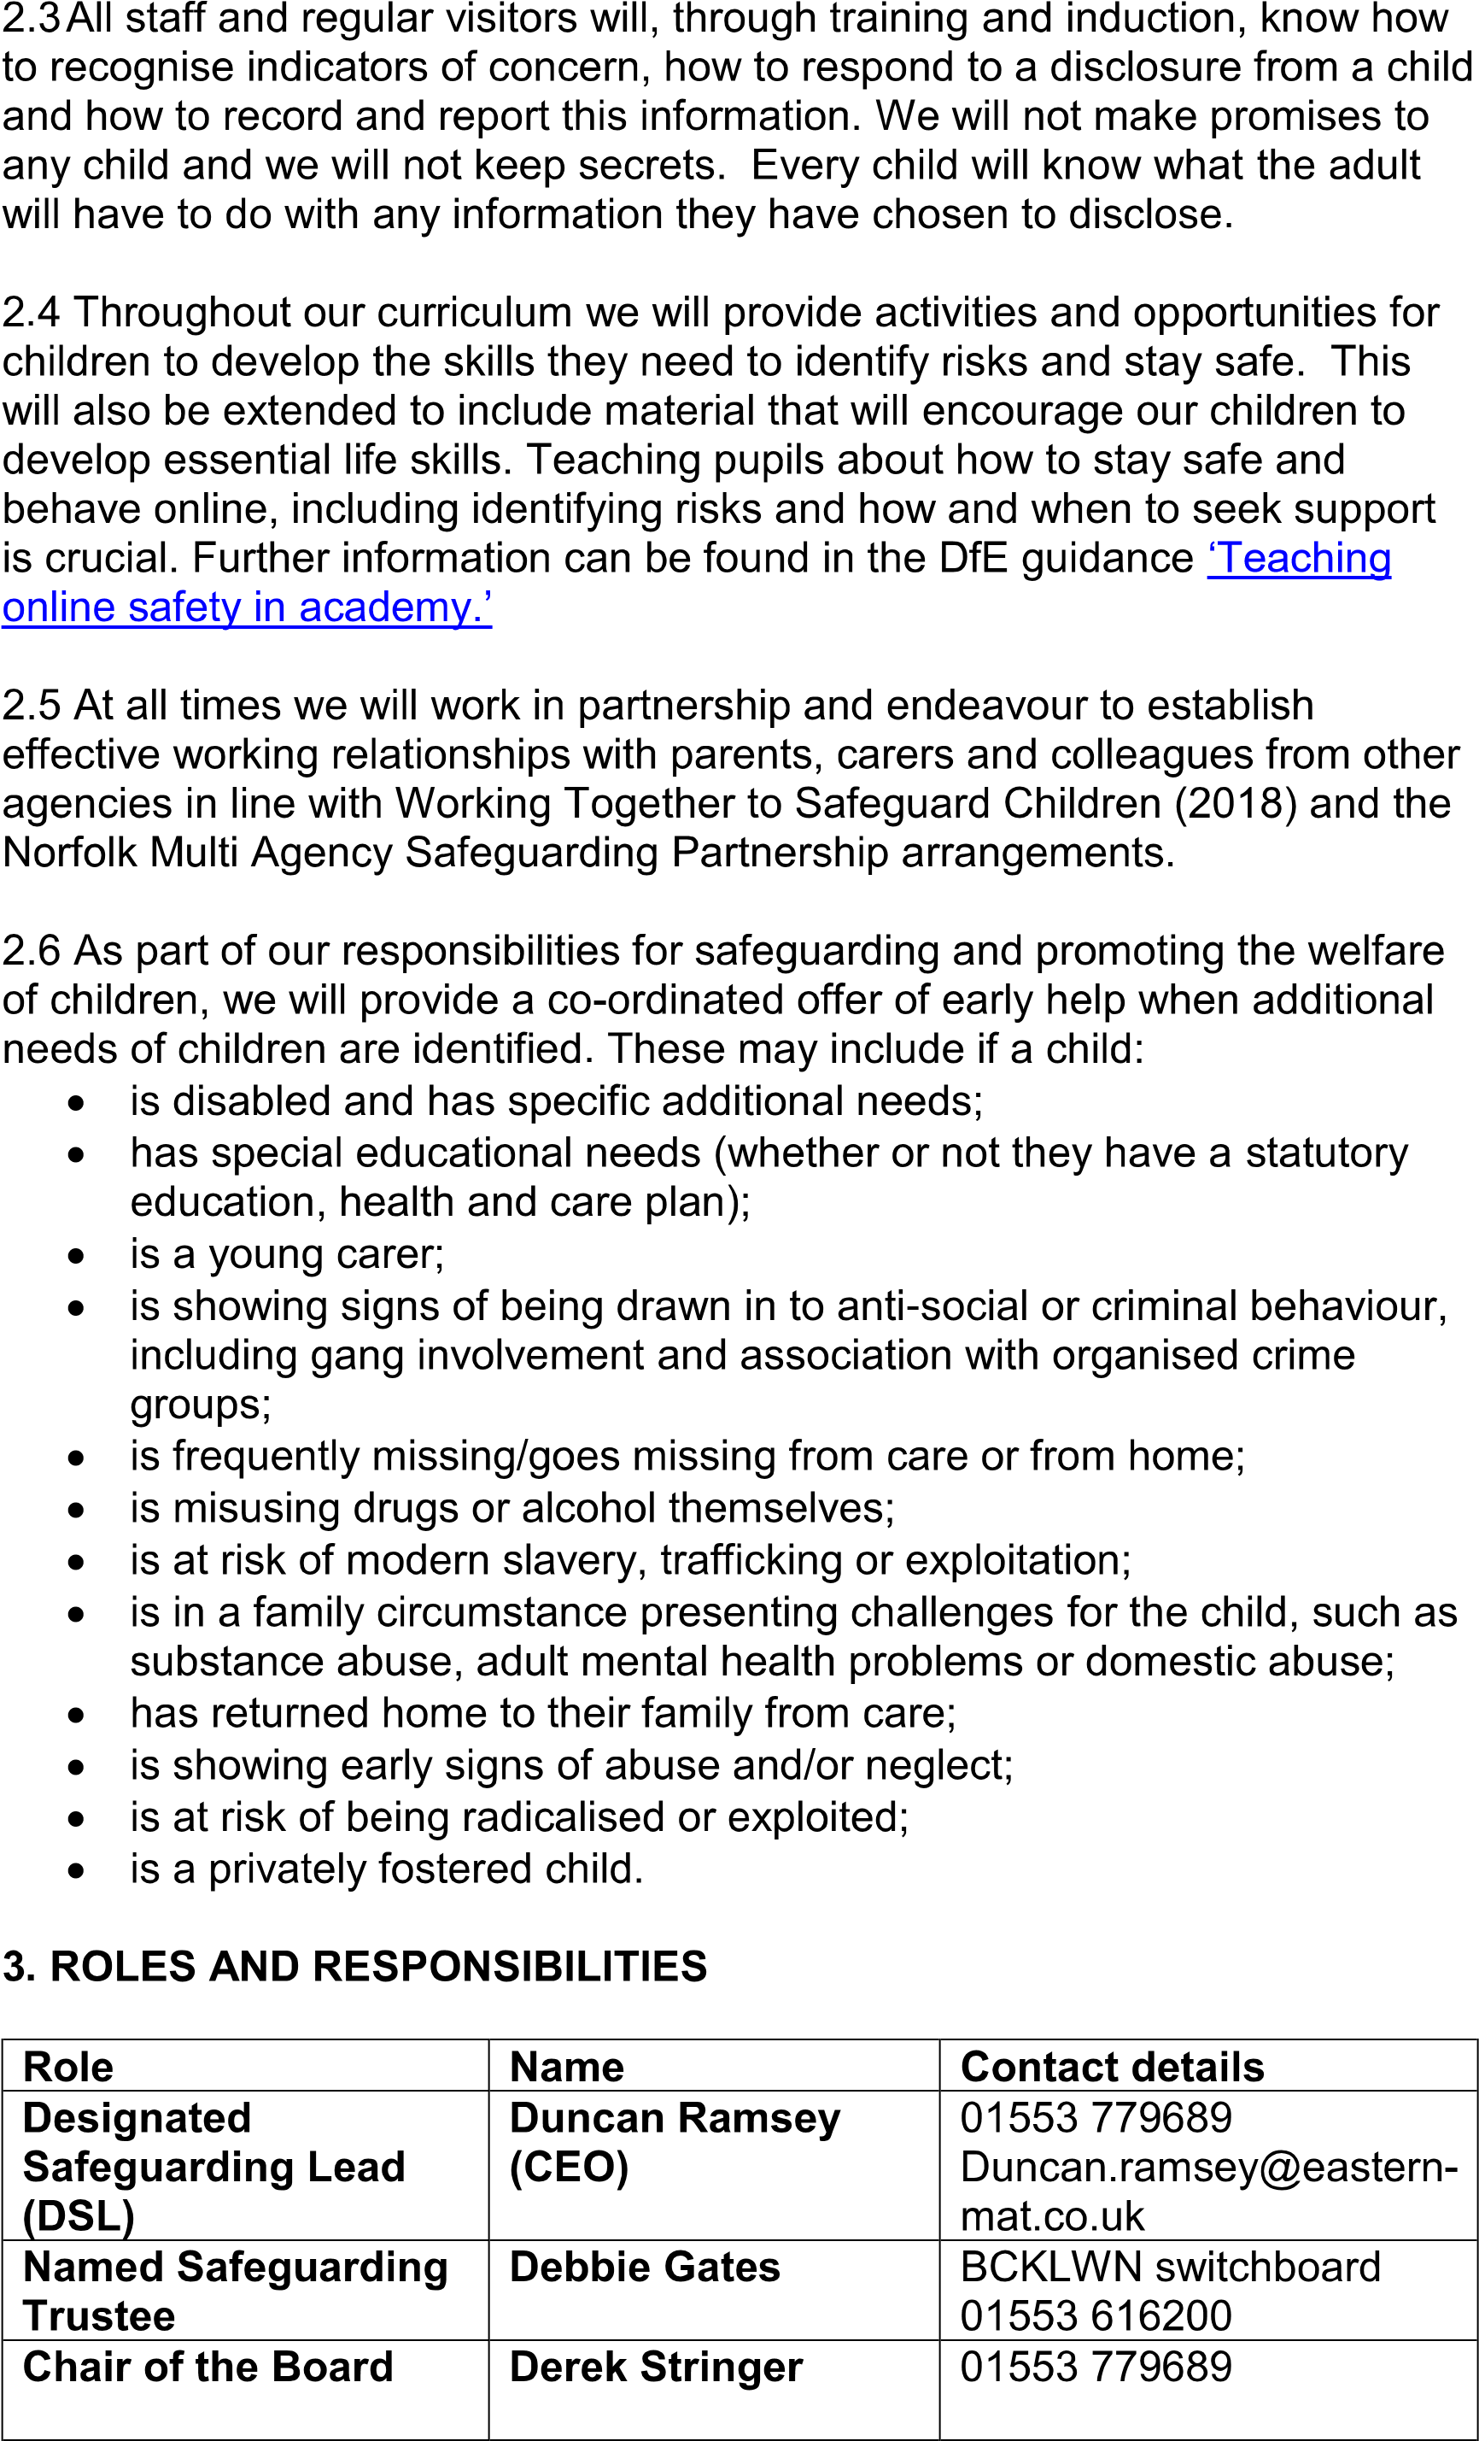
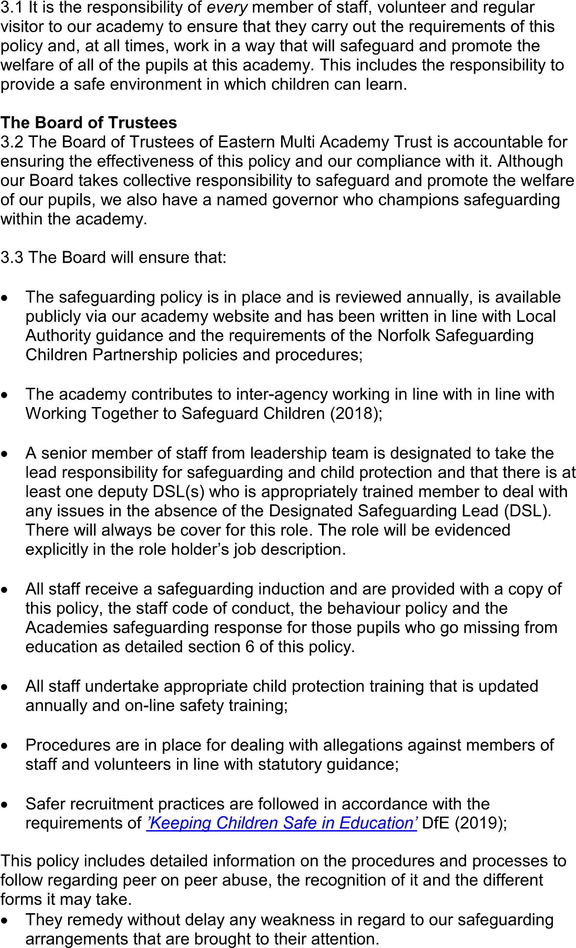

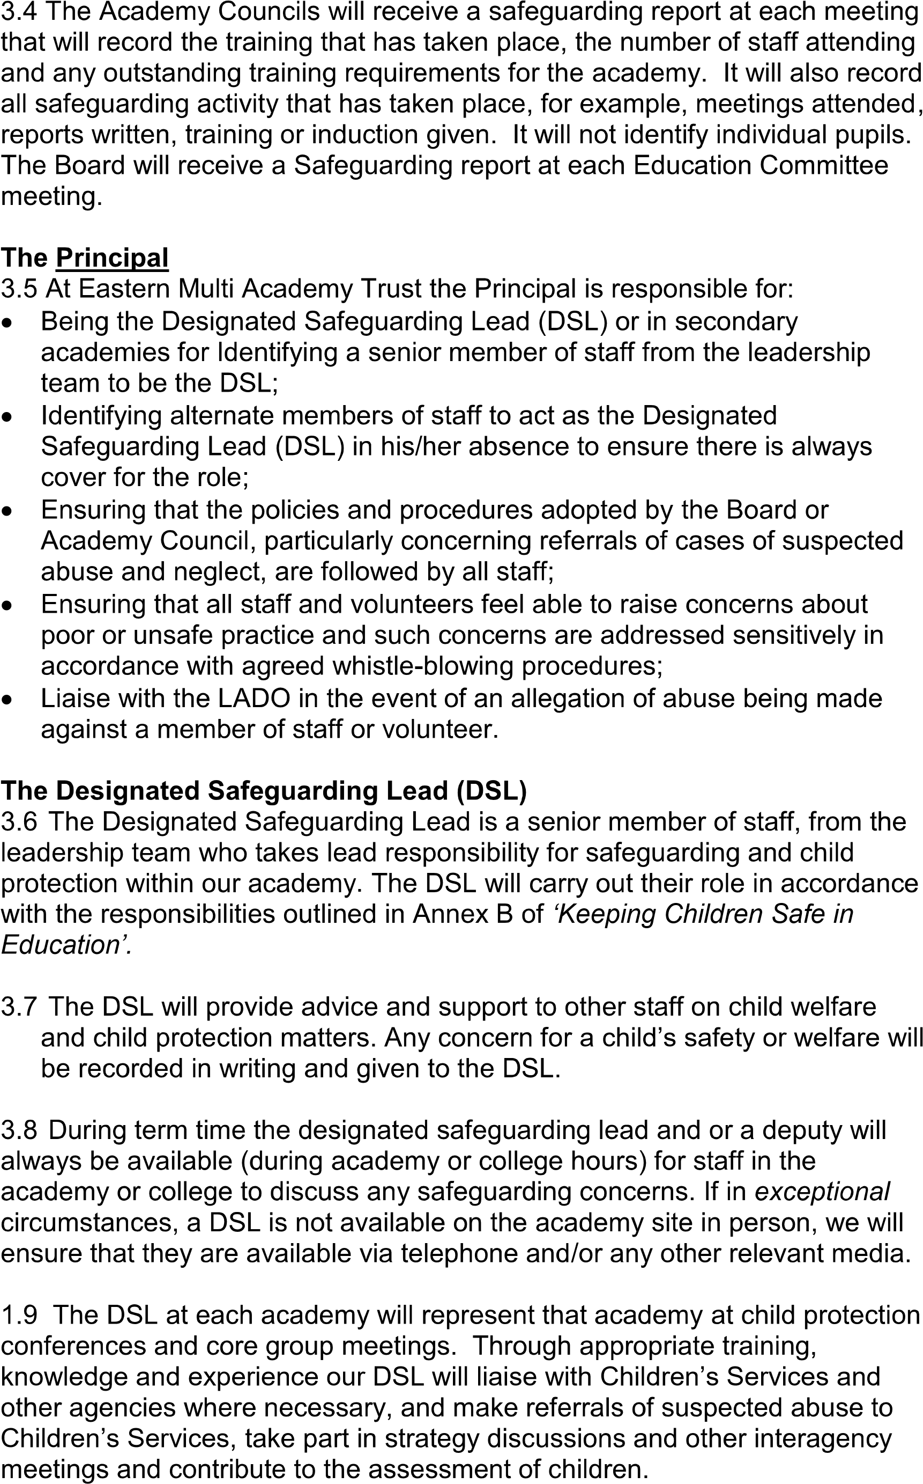
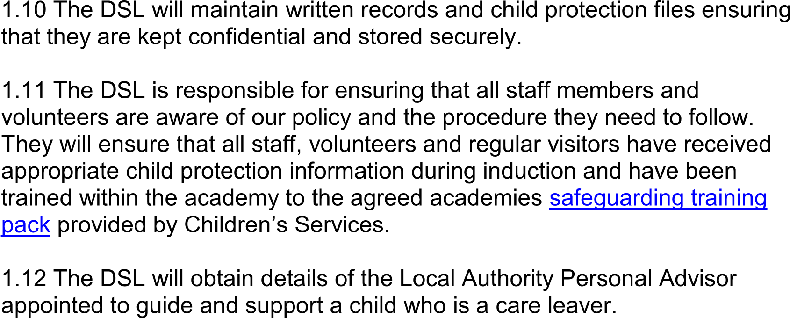
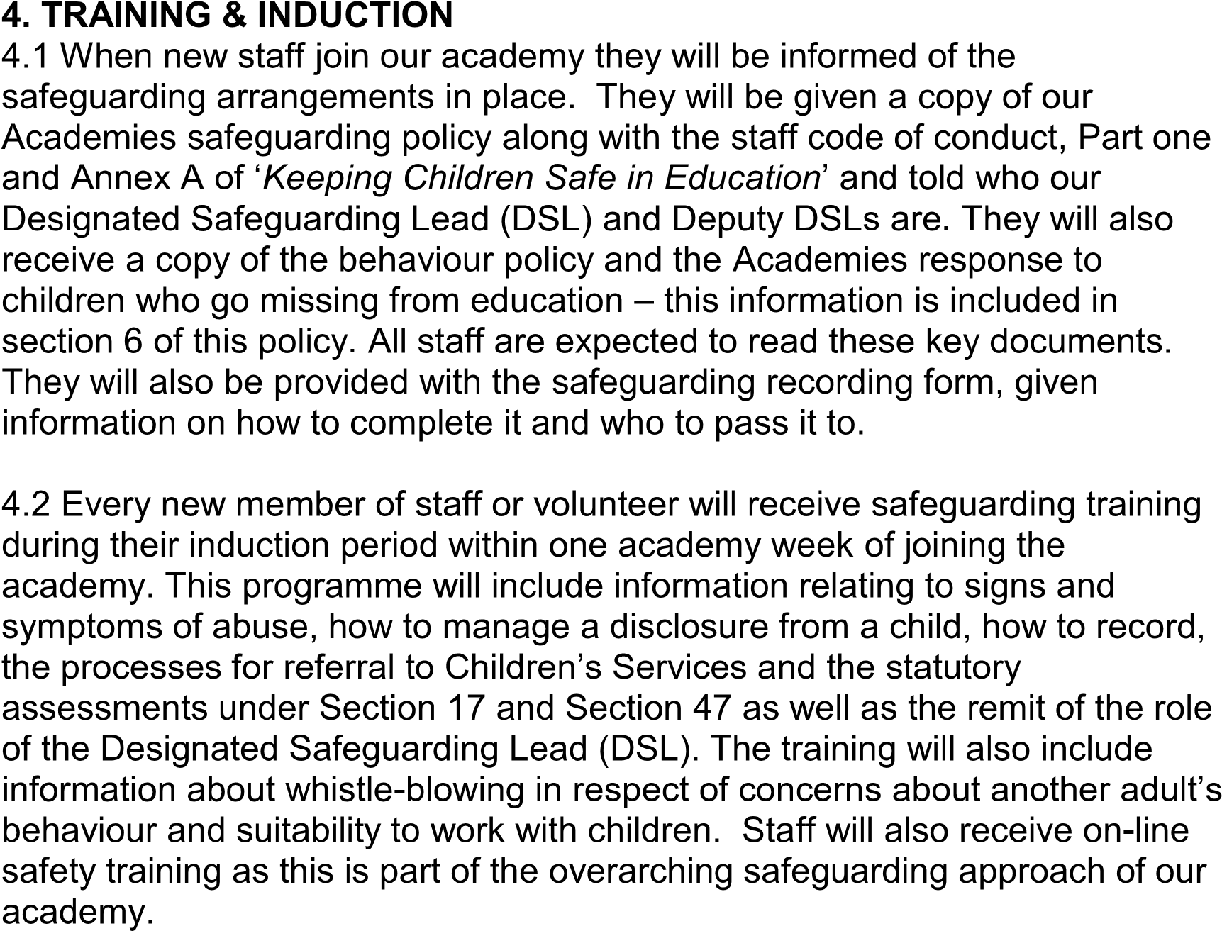
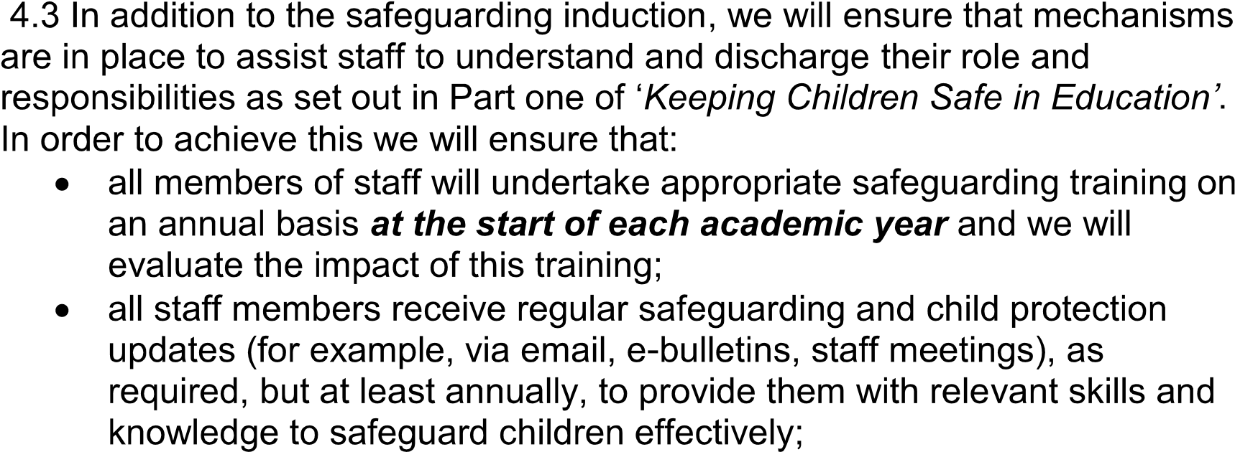
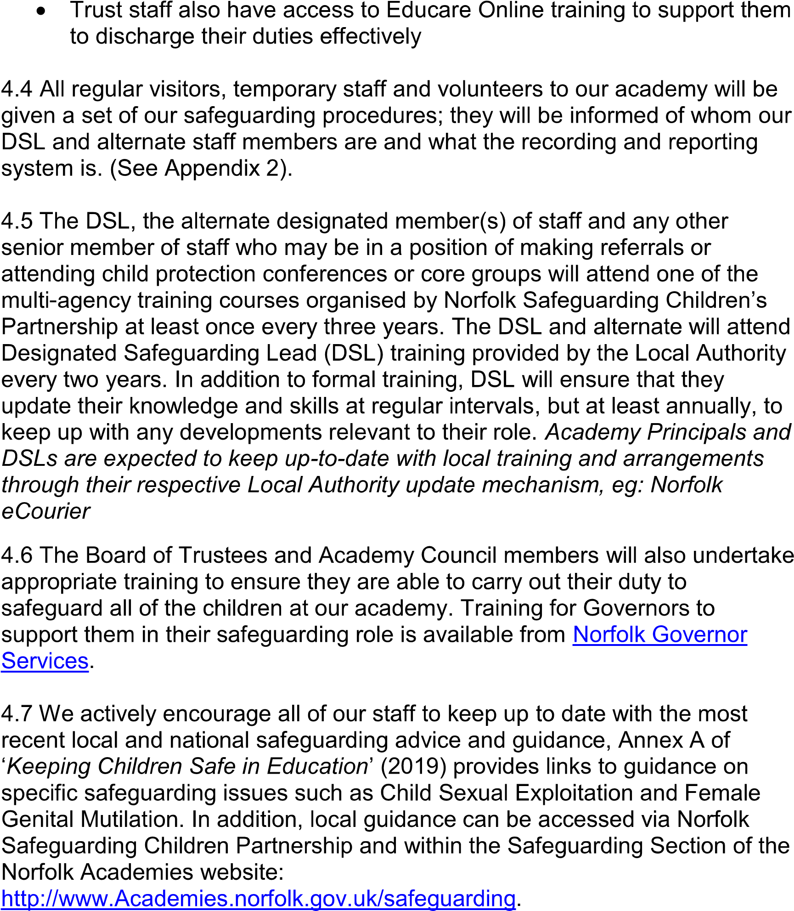
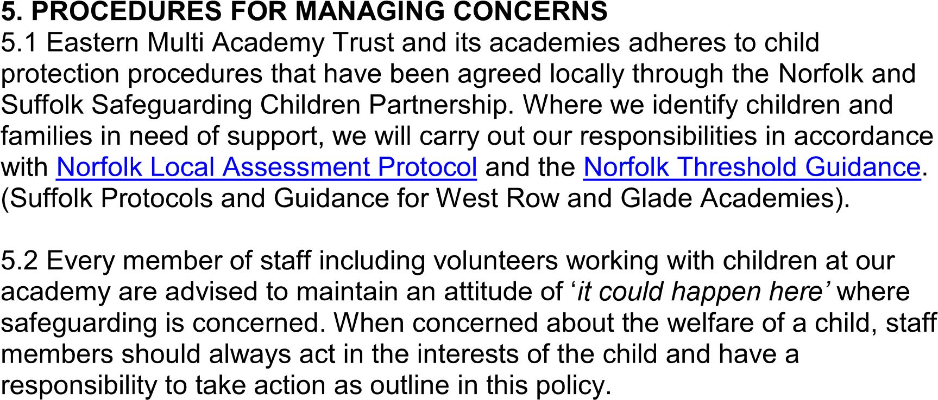

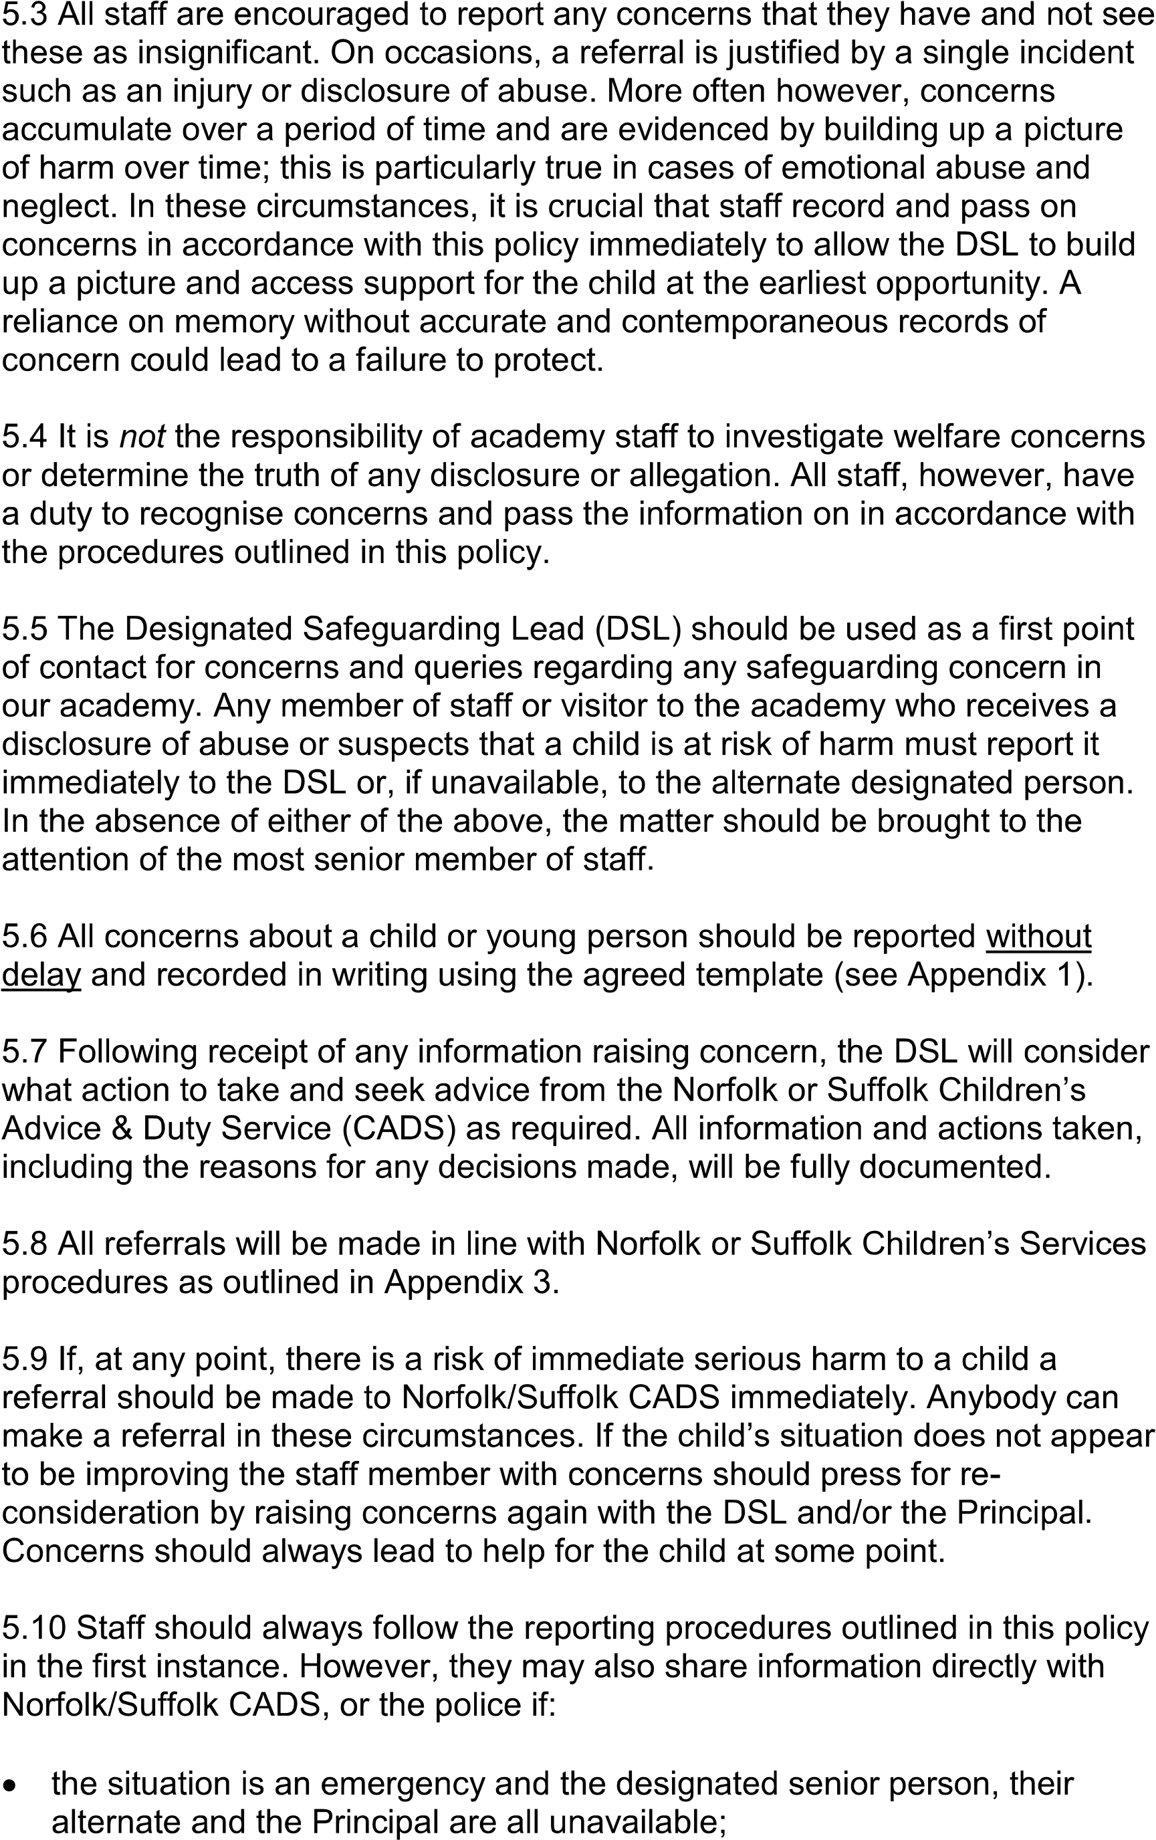
they are convinced that a direct report is the only way to ensure the pupil’s
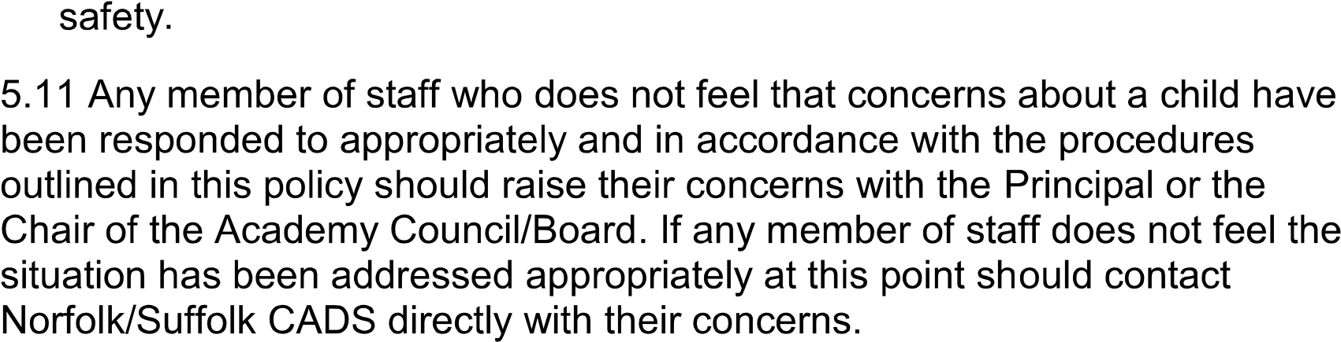
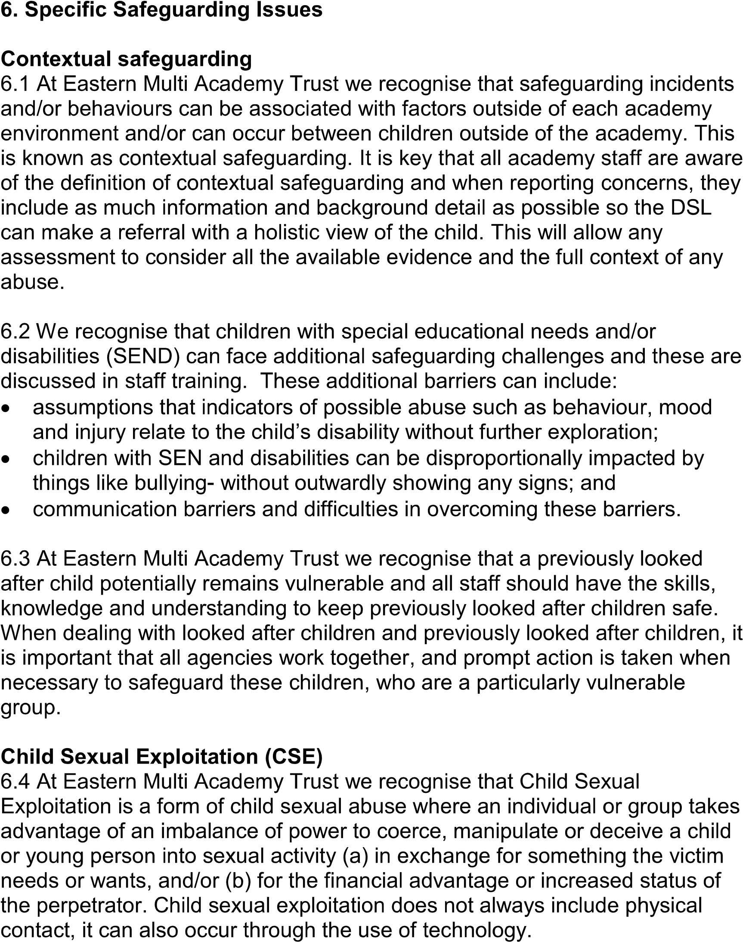
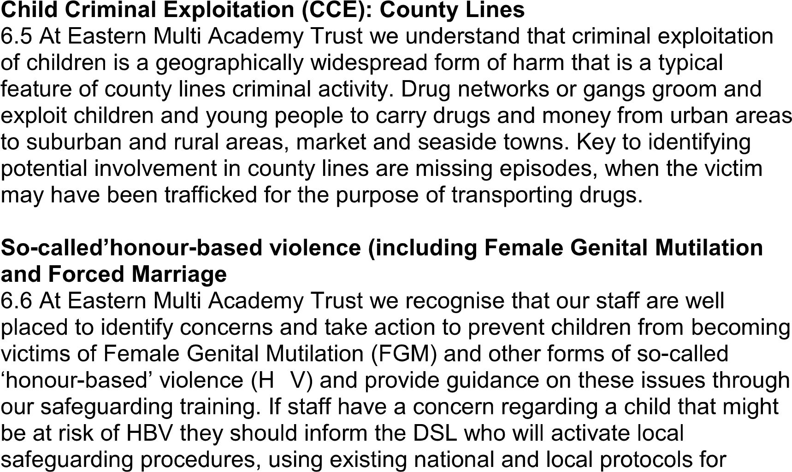
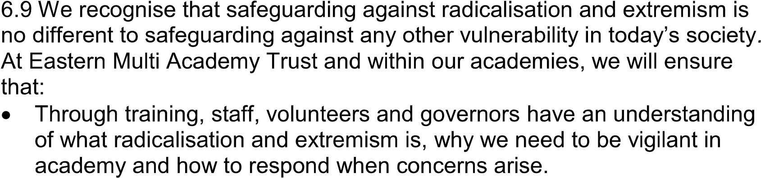
multiagency liaison with police and children’s social care.
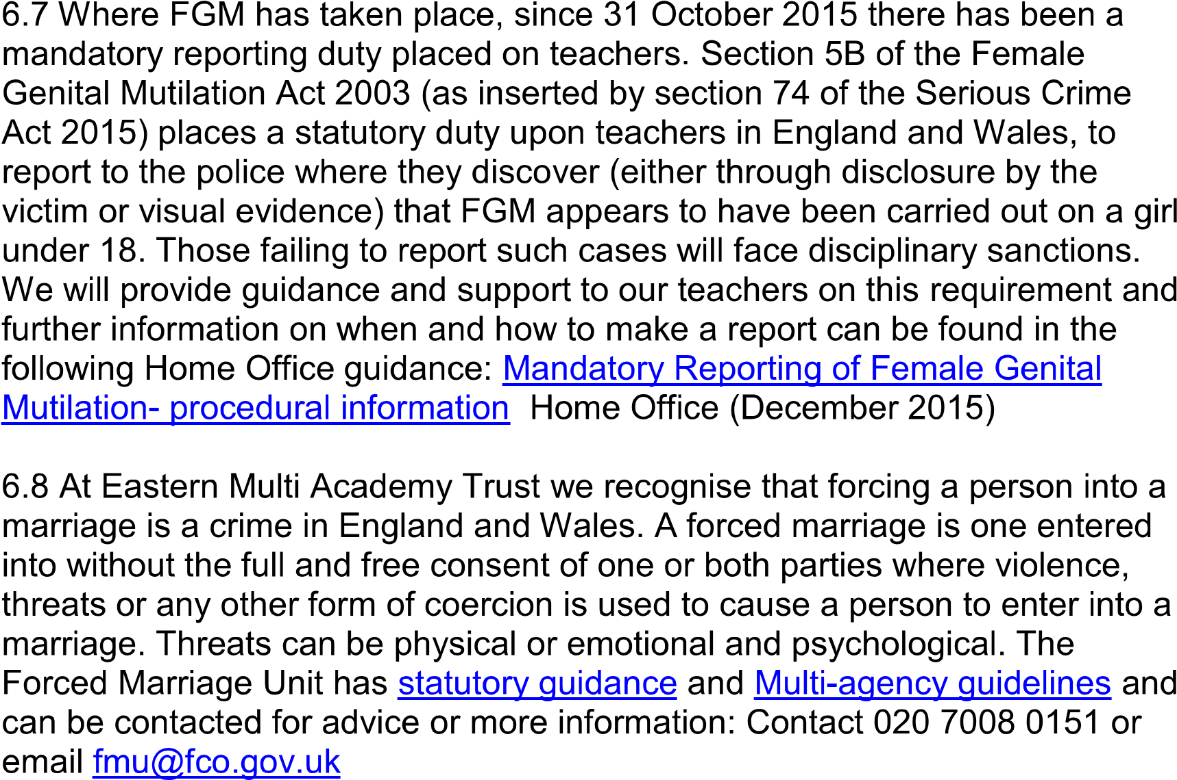
Preventing radicalisation and extremism
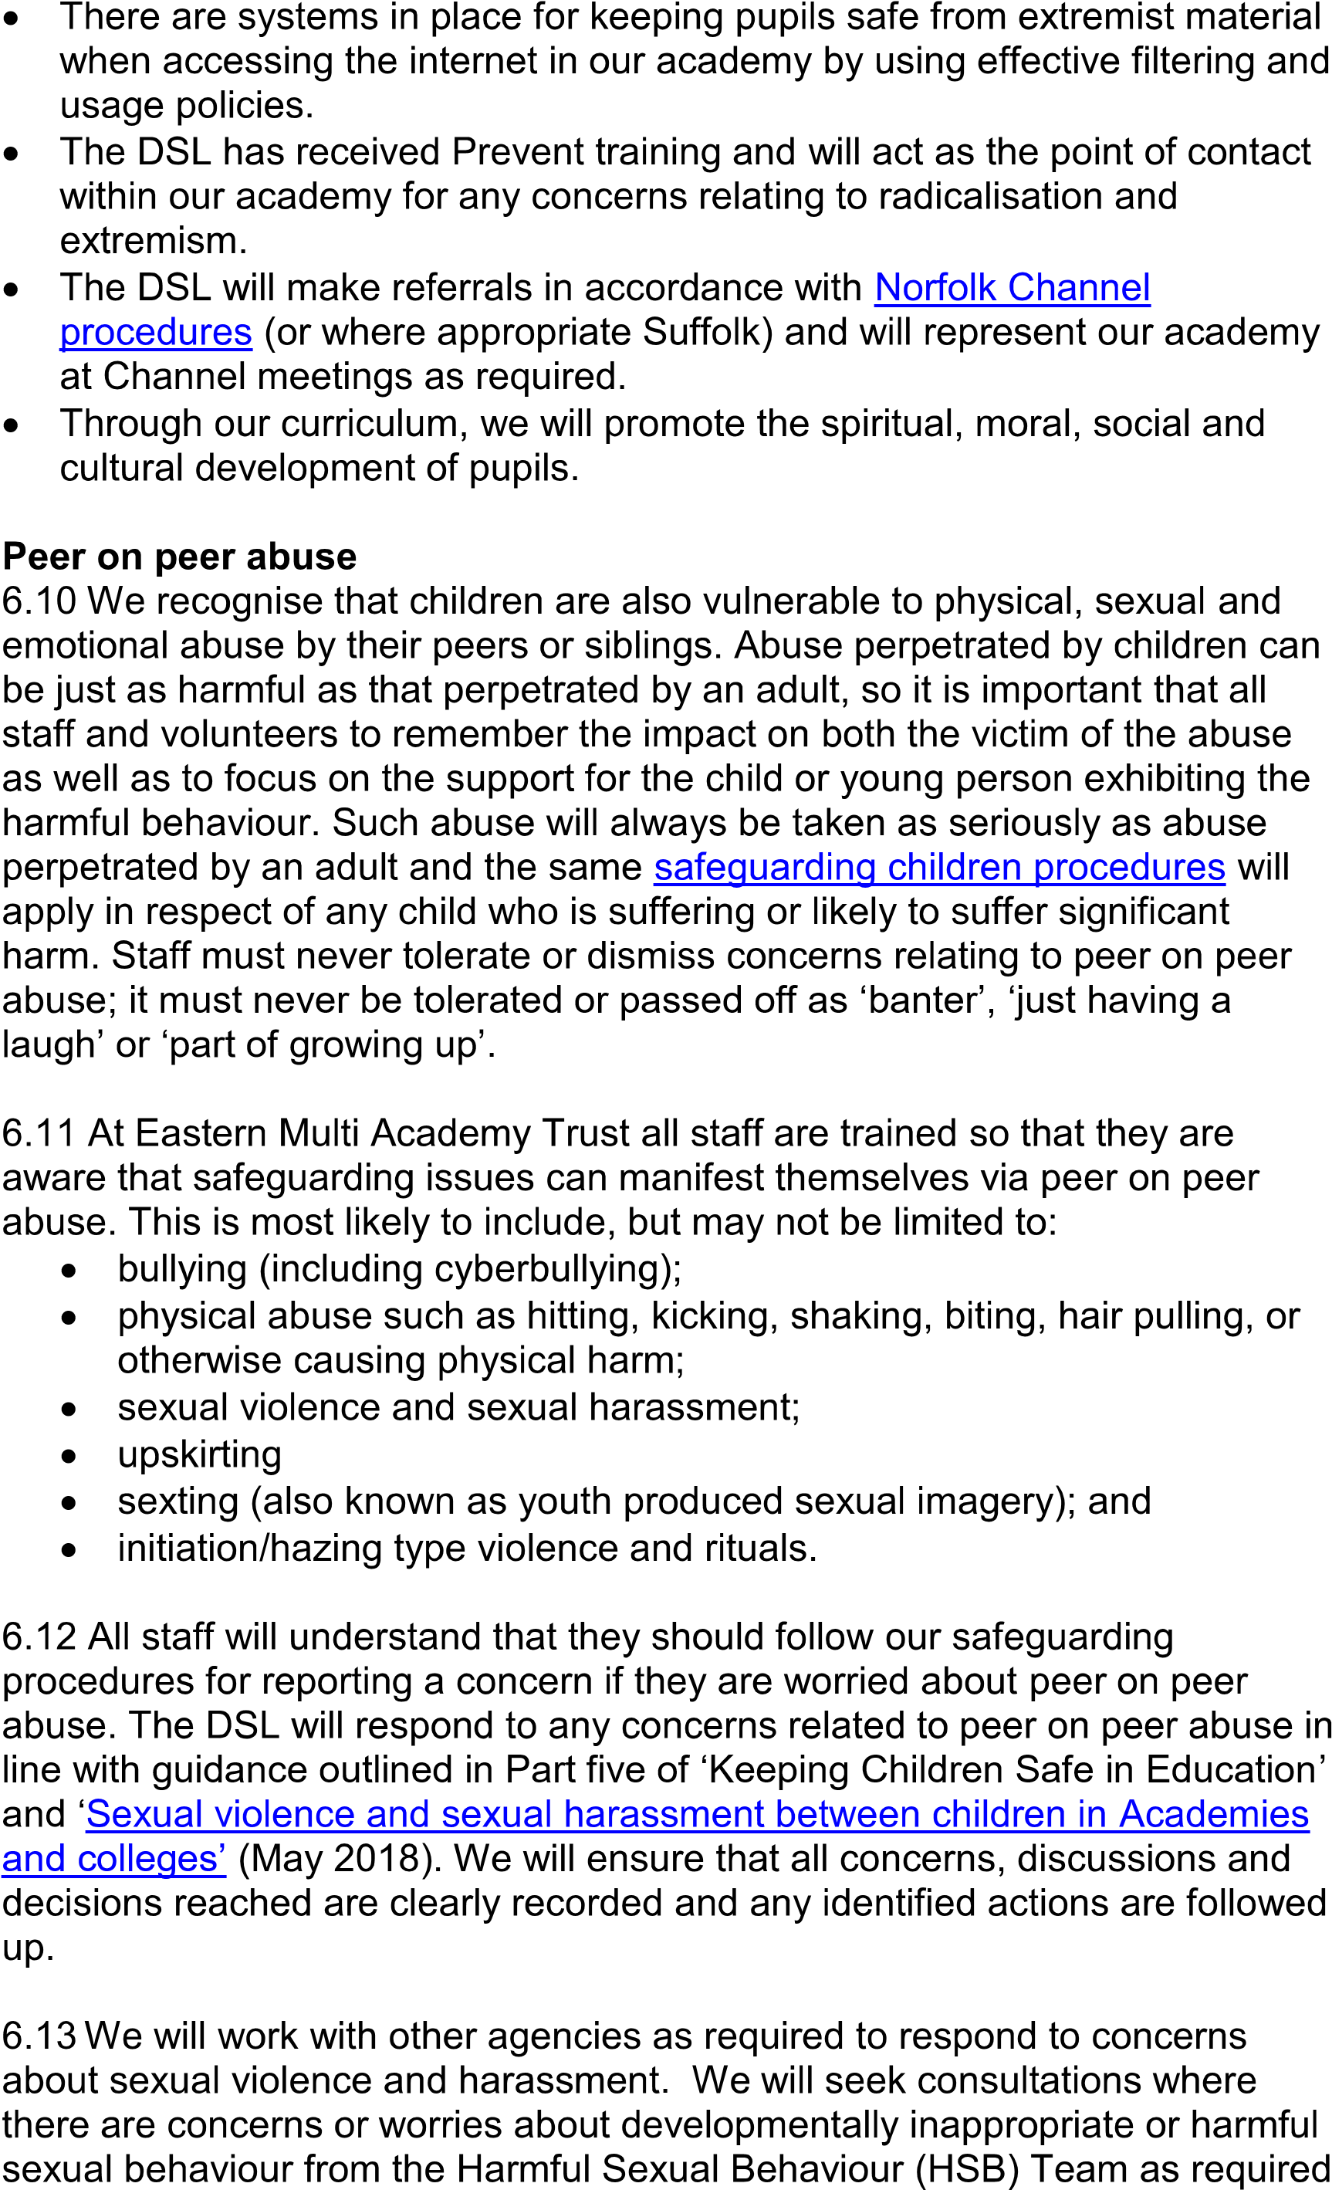
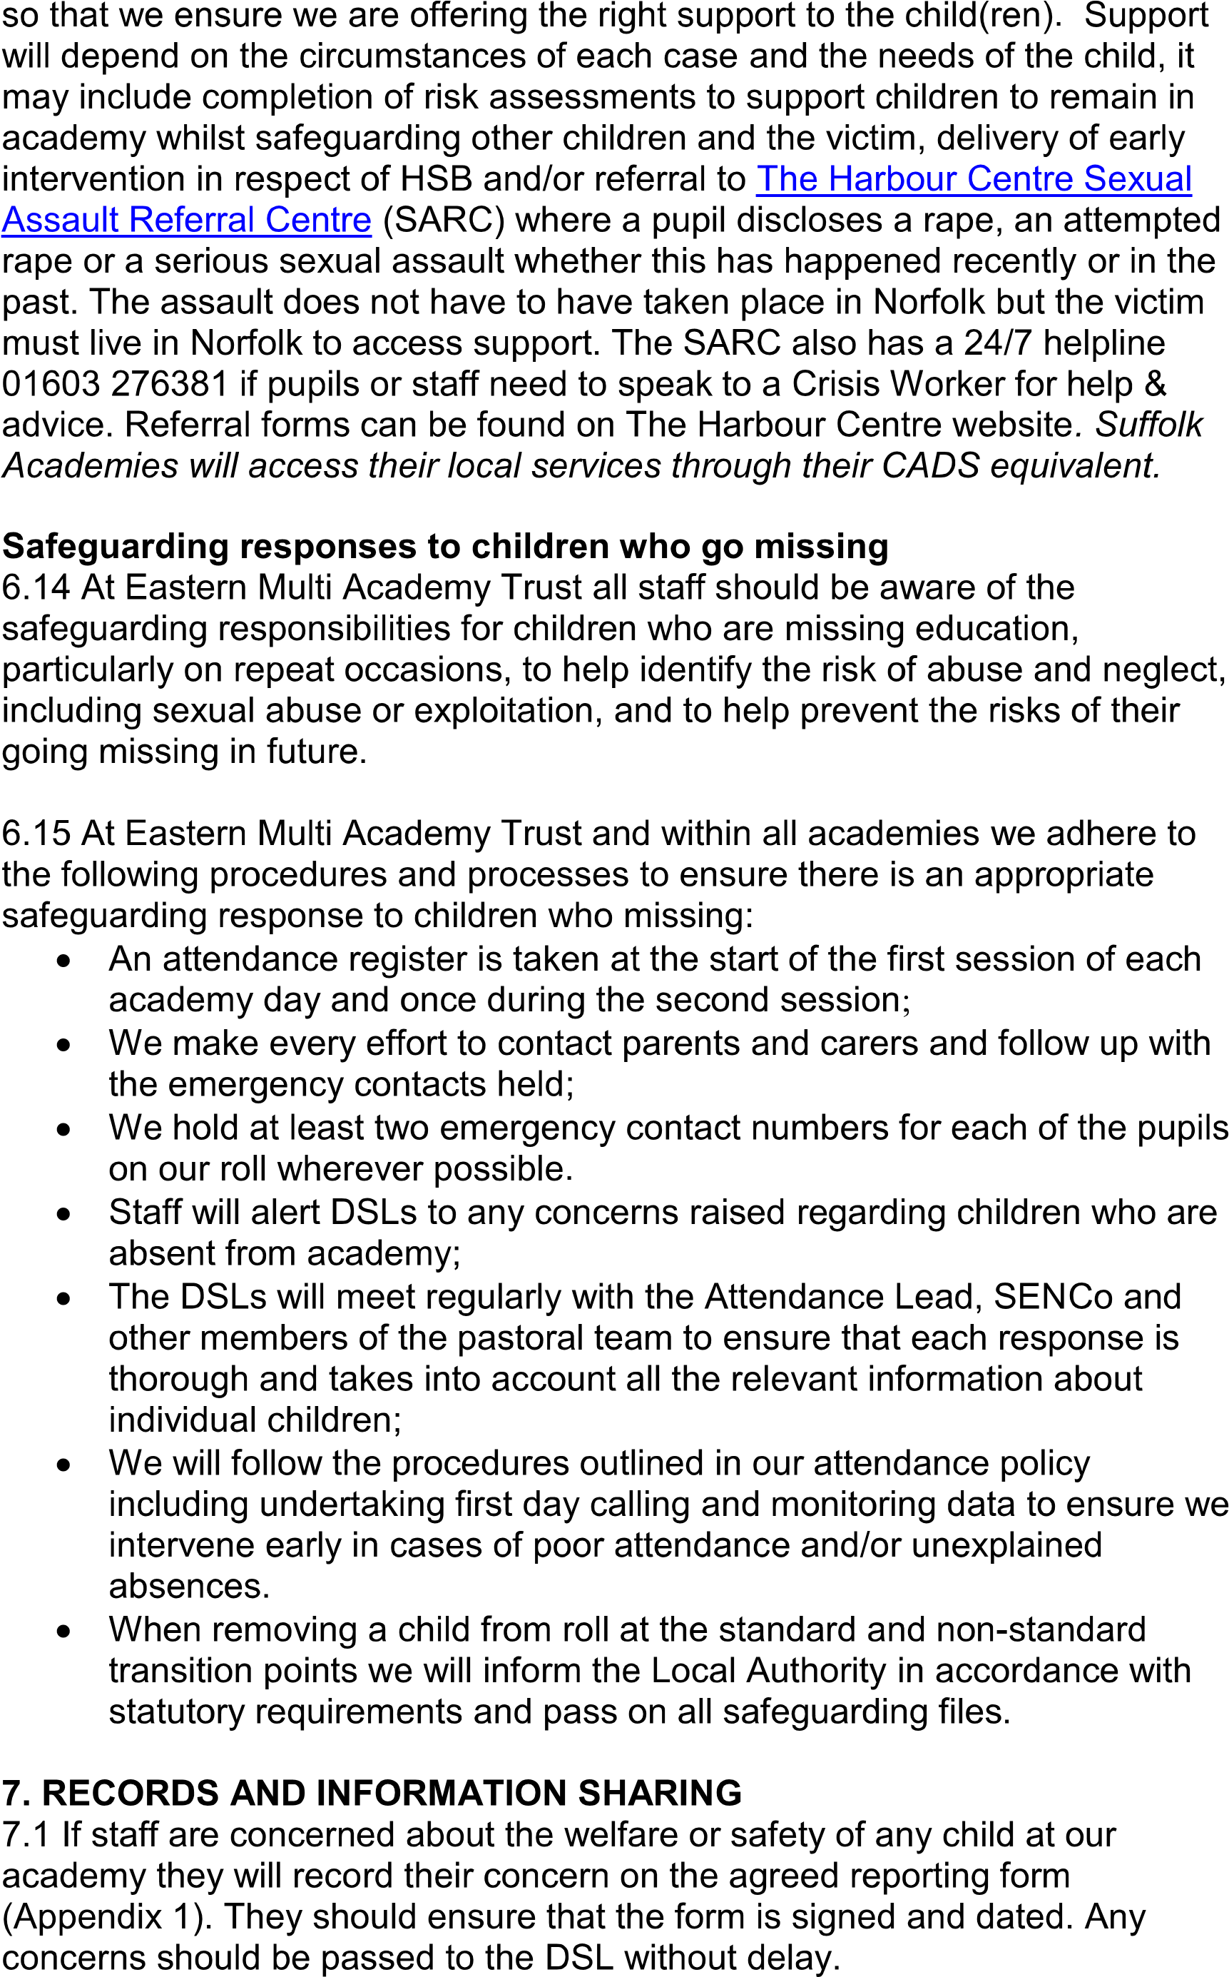

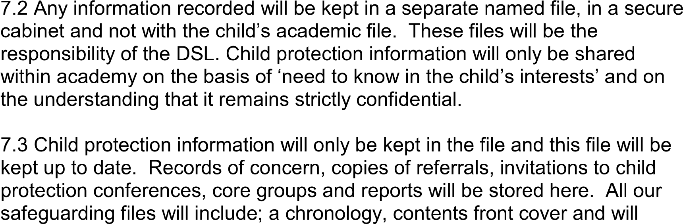
record significant events in the child’s life.
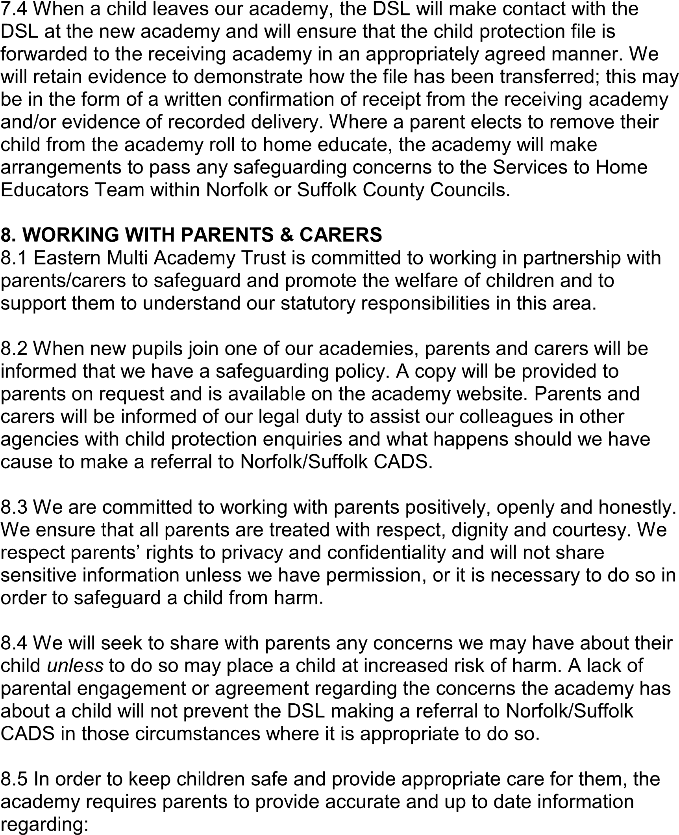
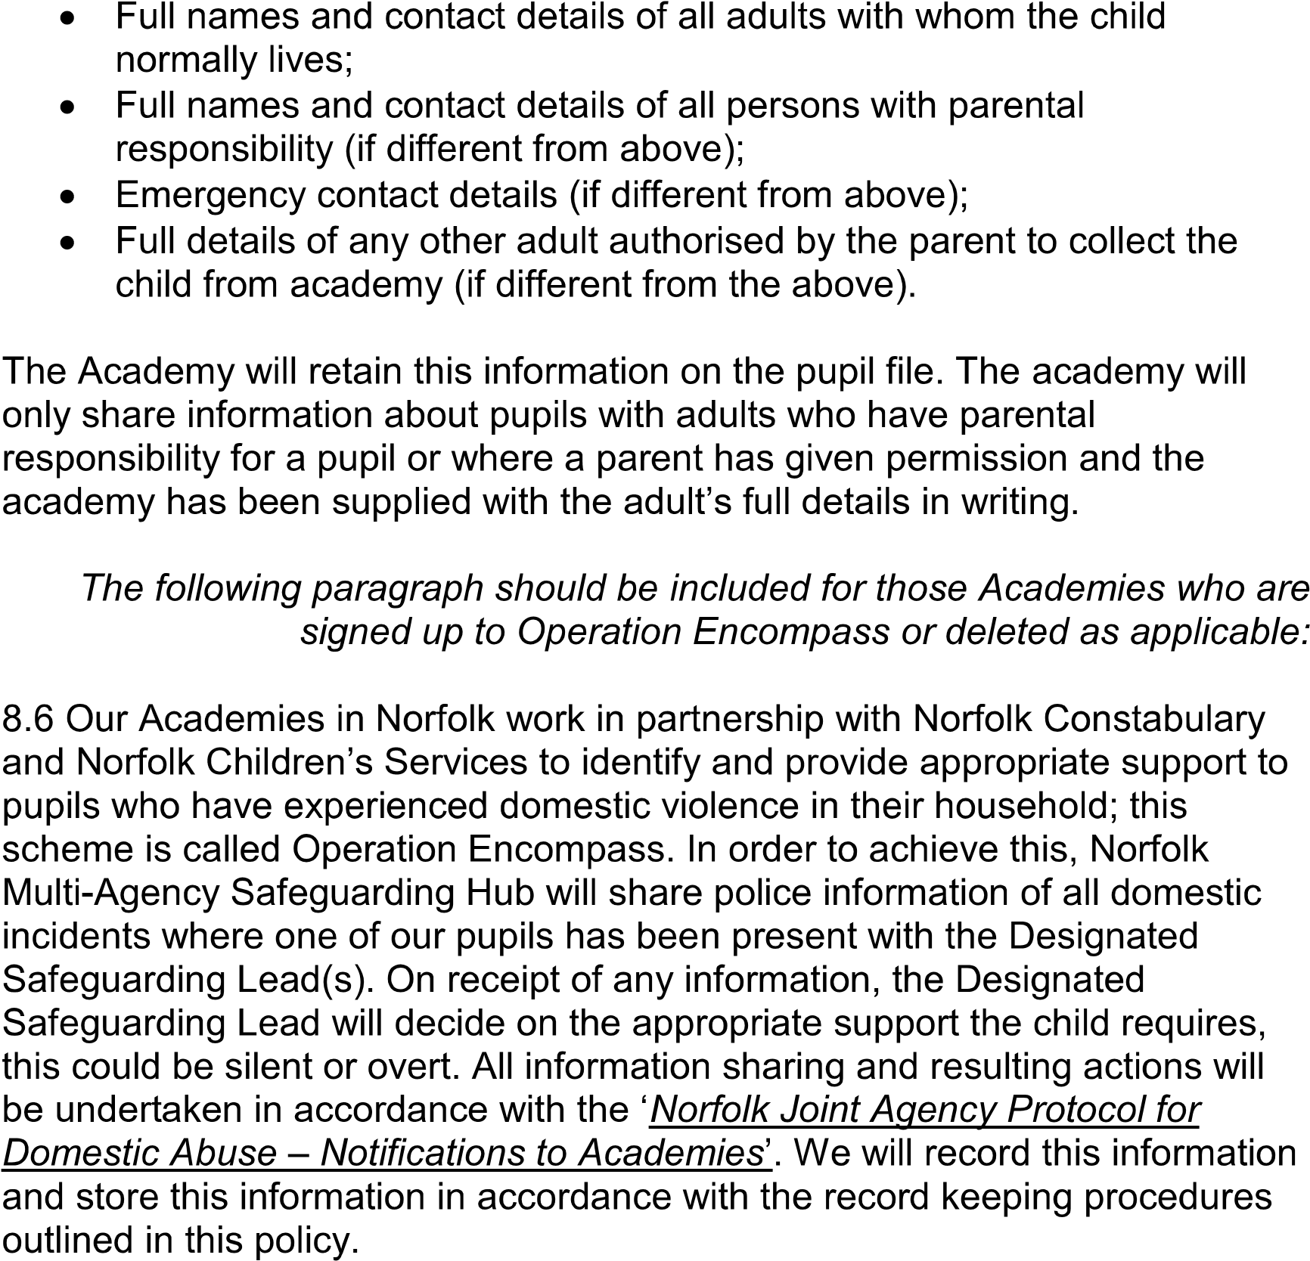
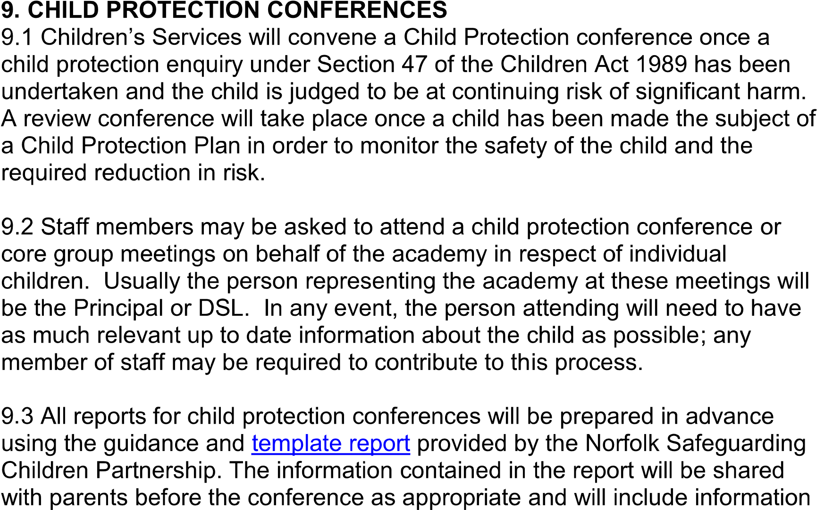
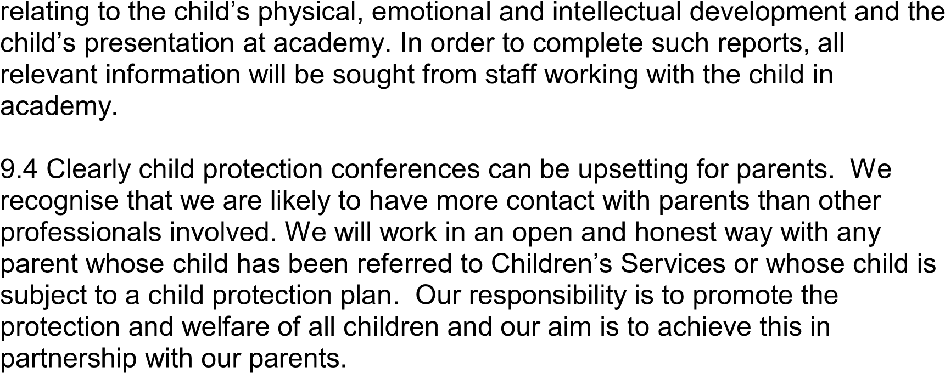
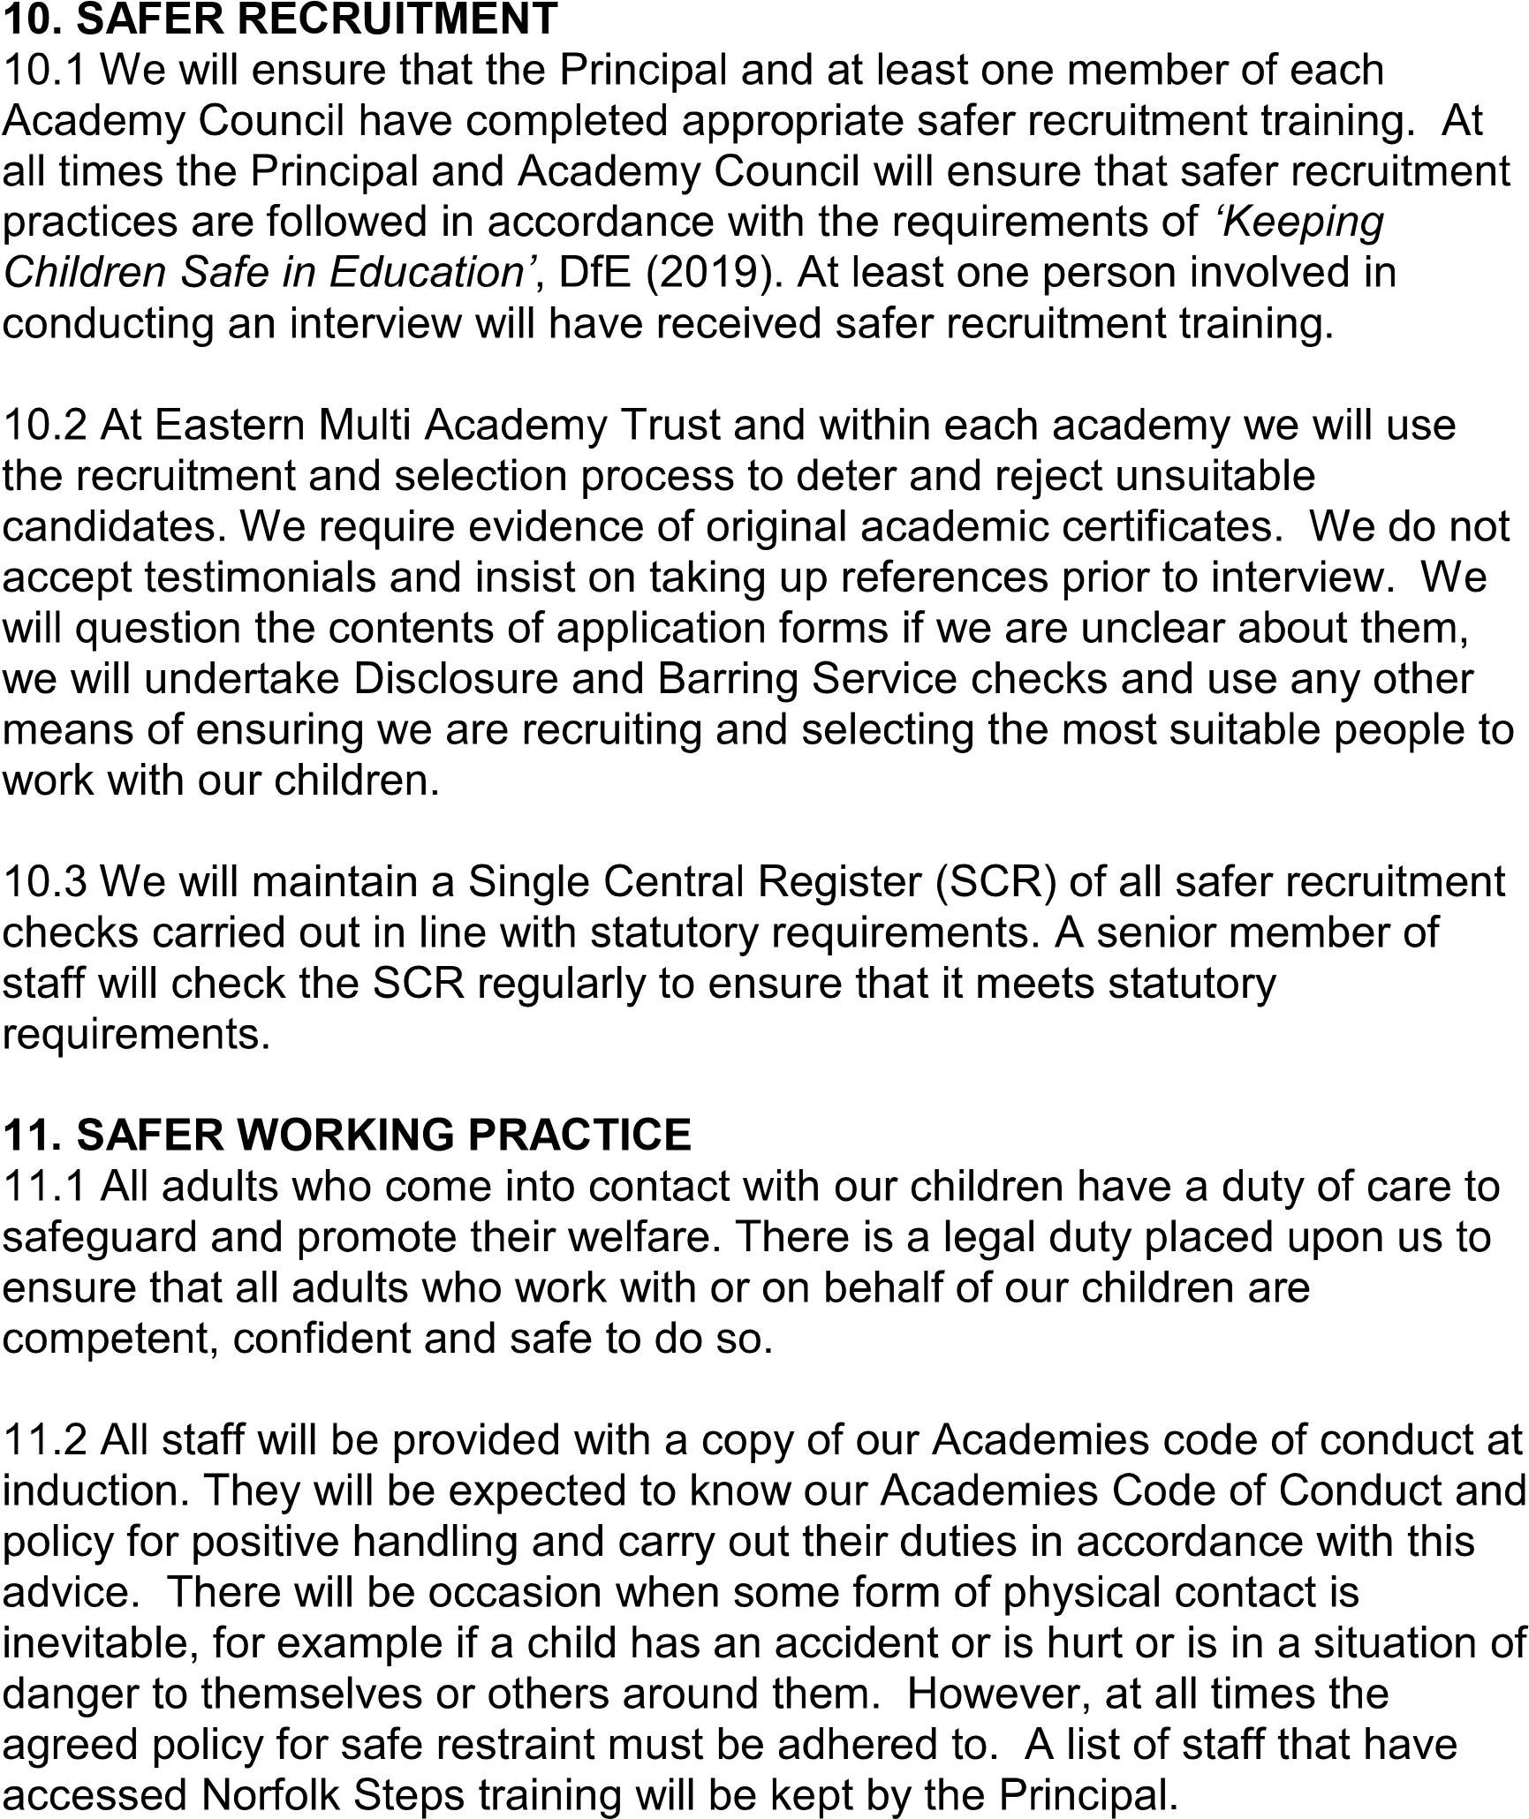

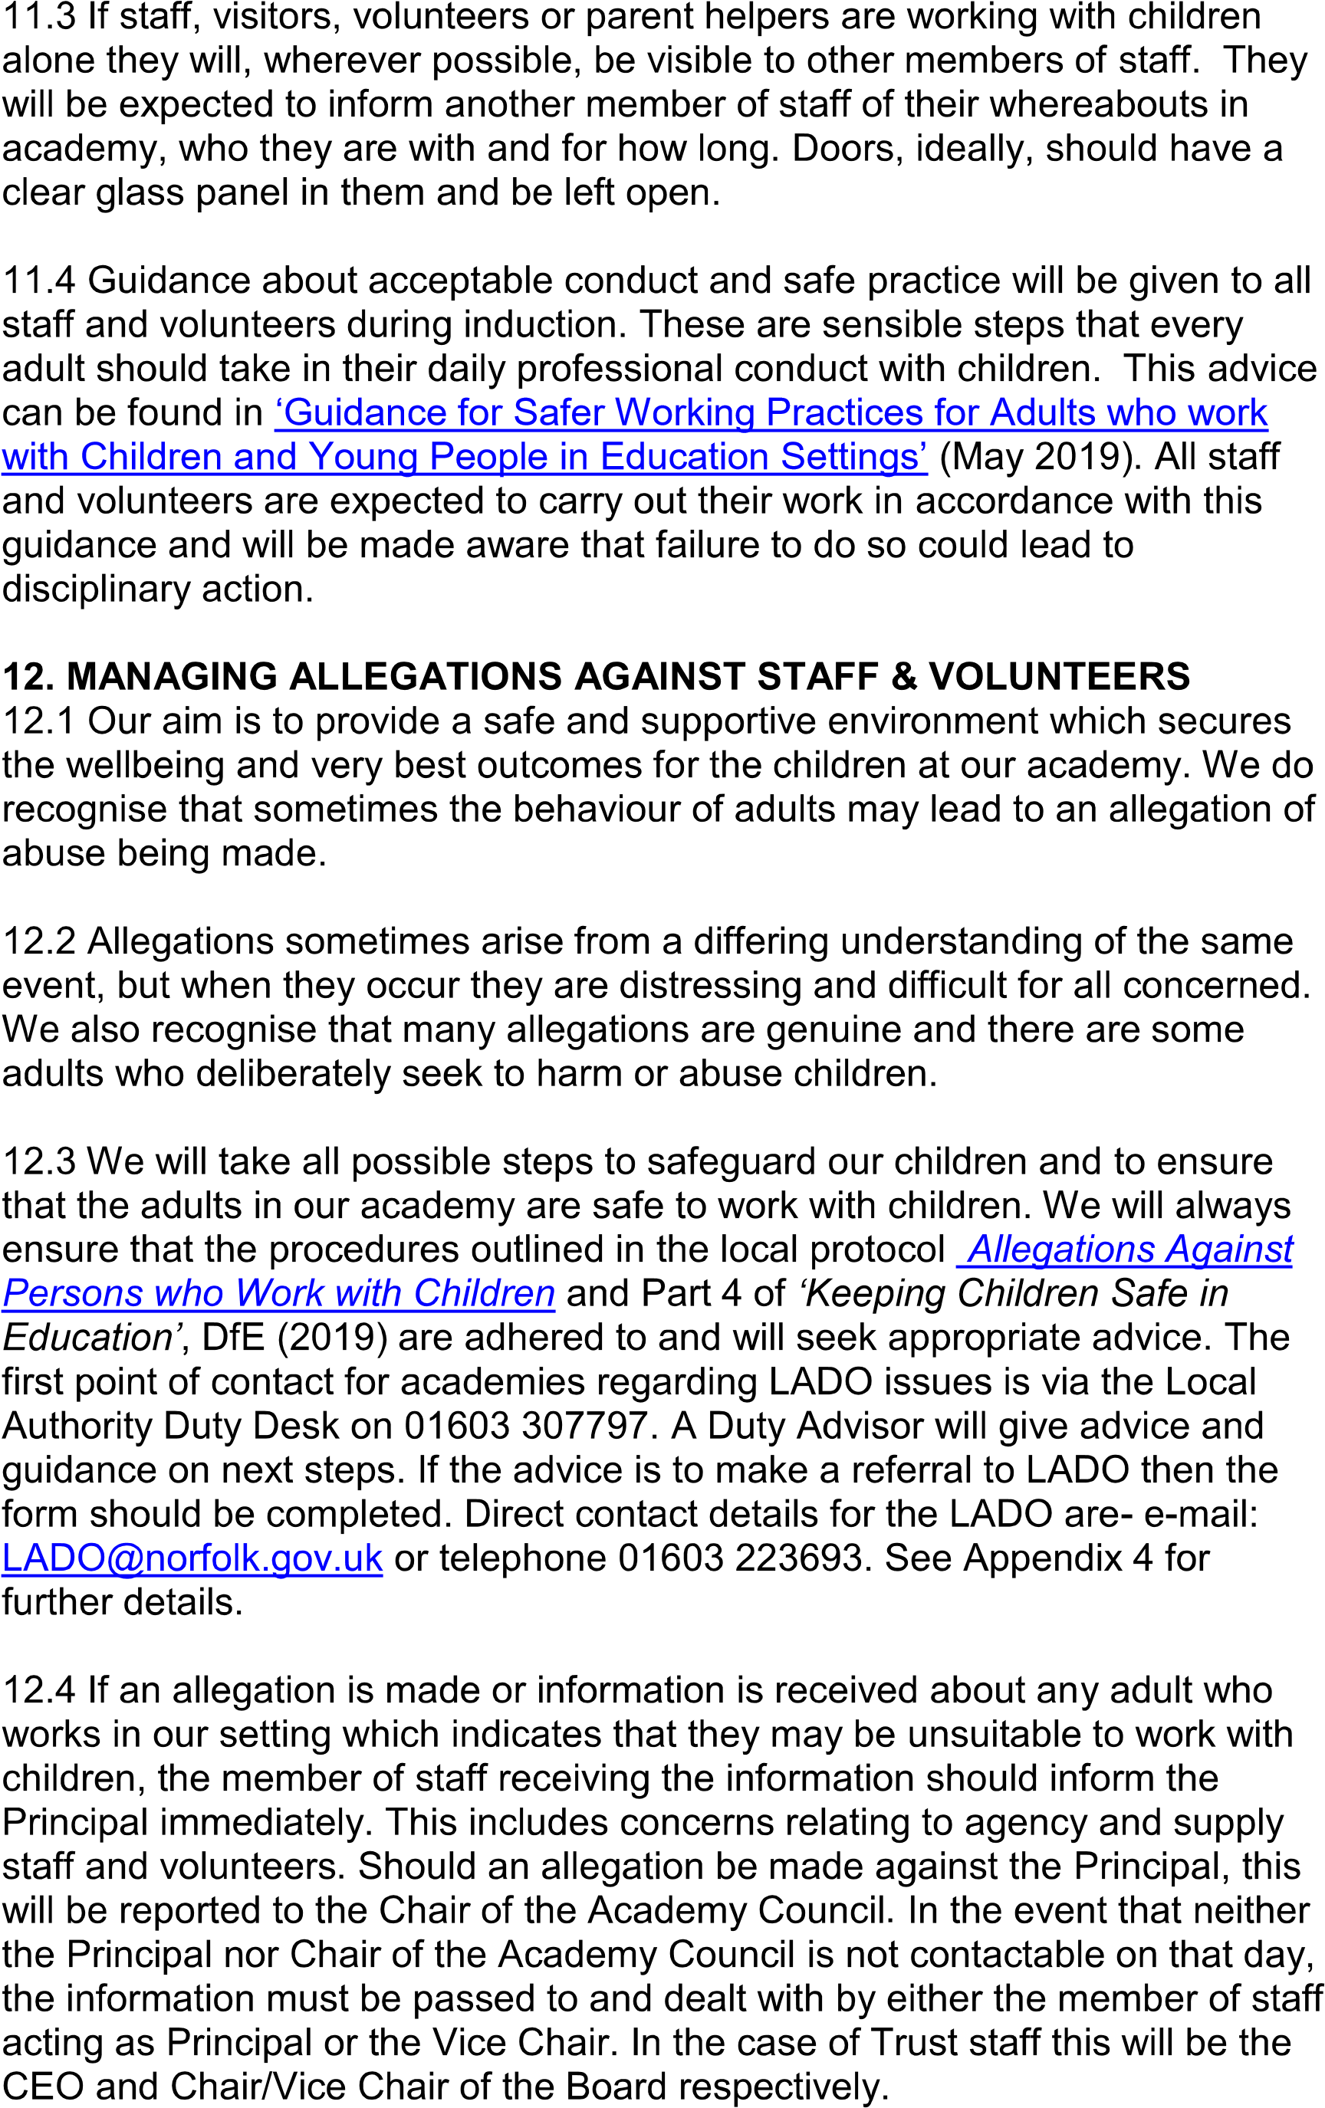
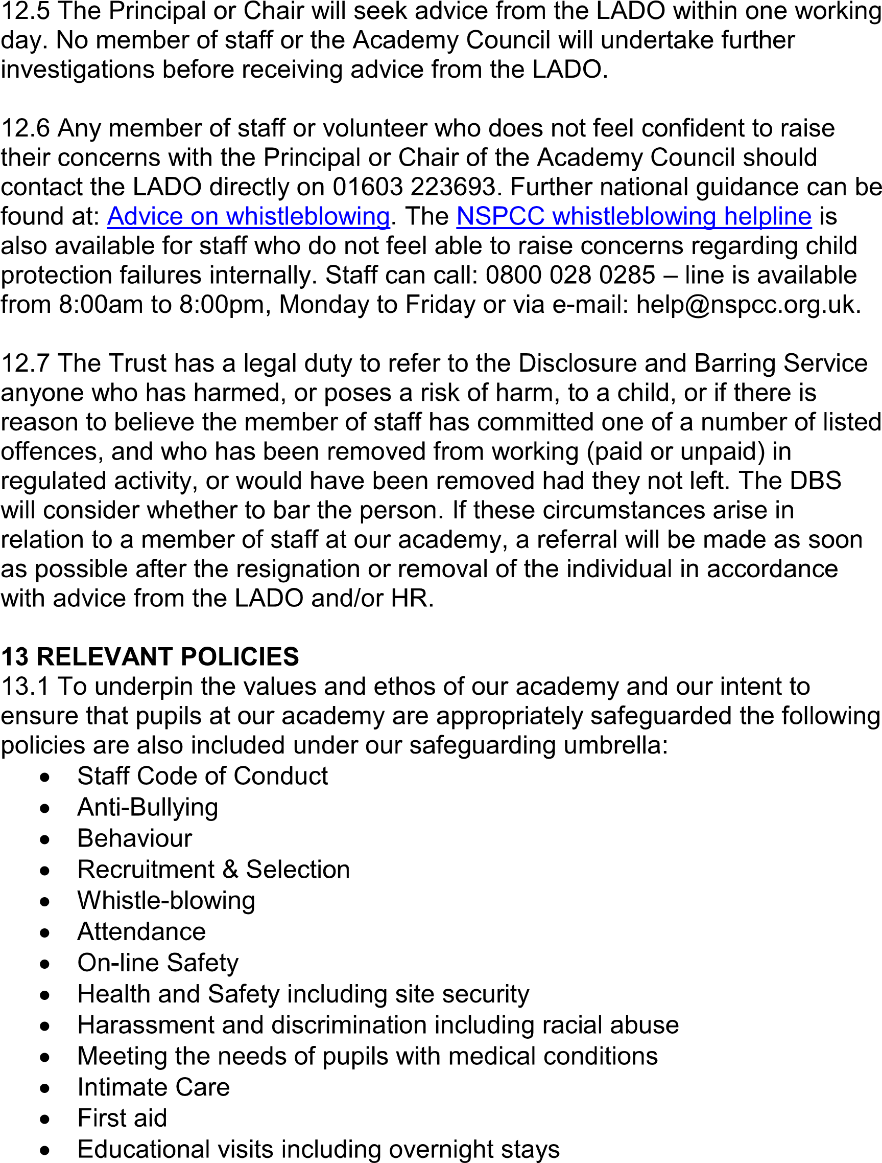
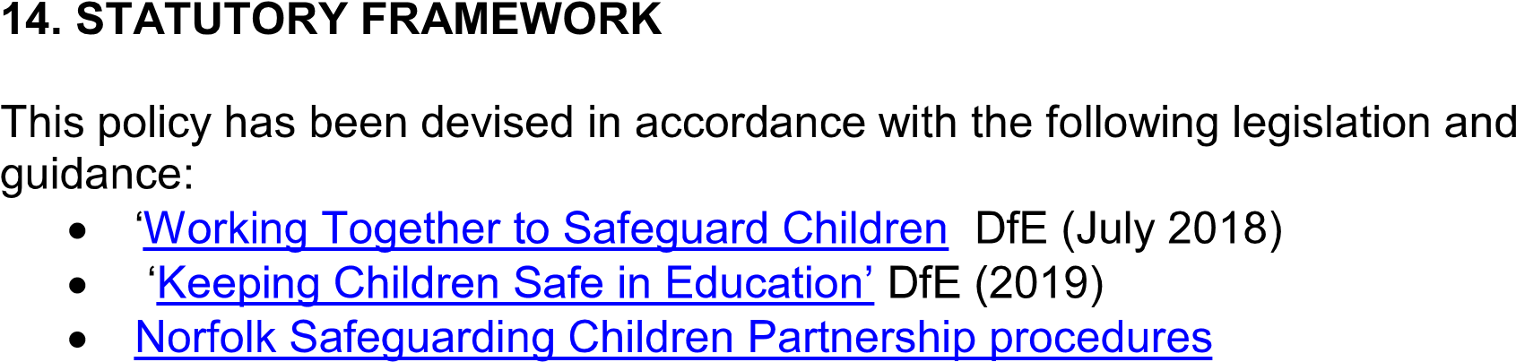

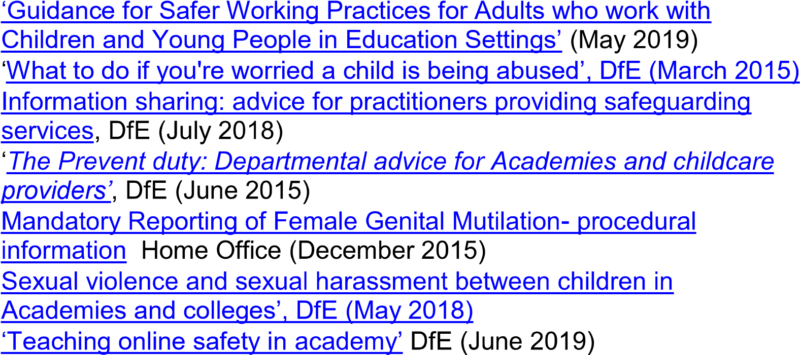

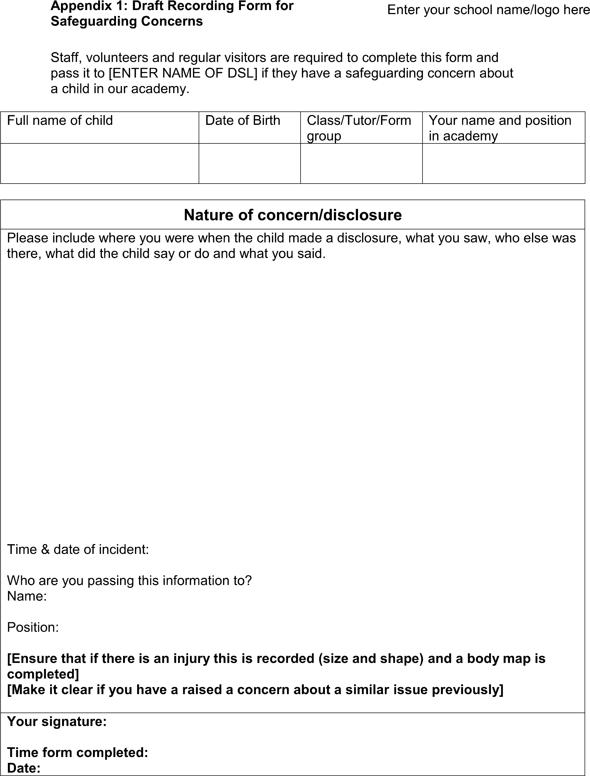
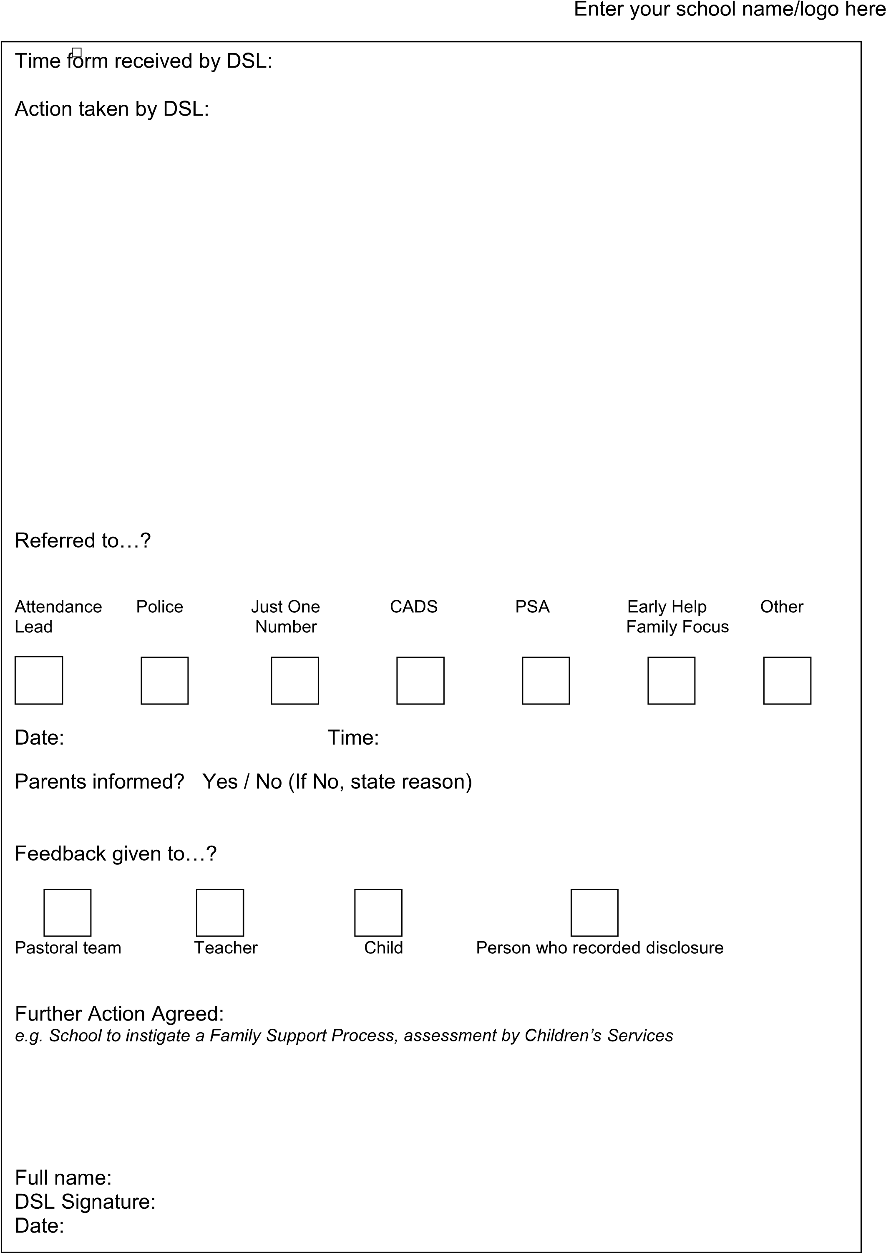

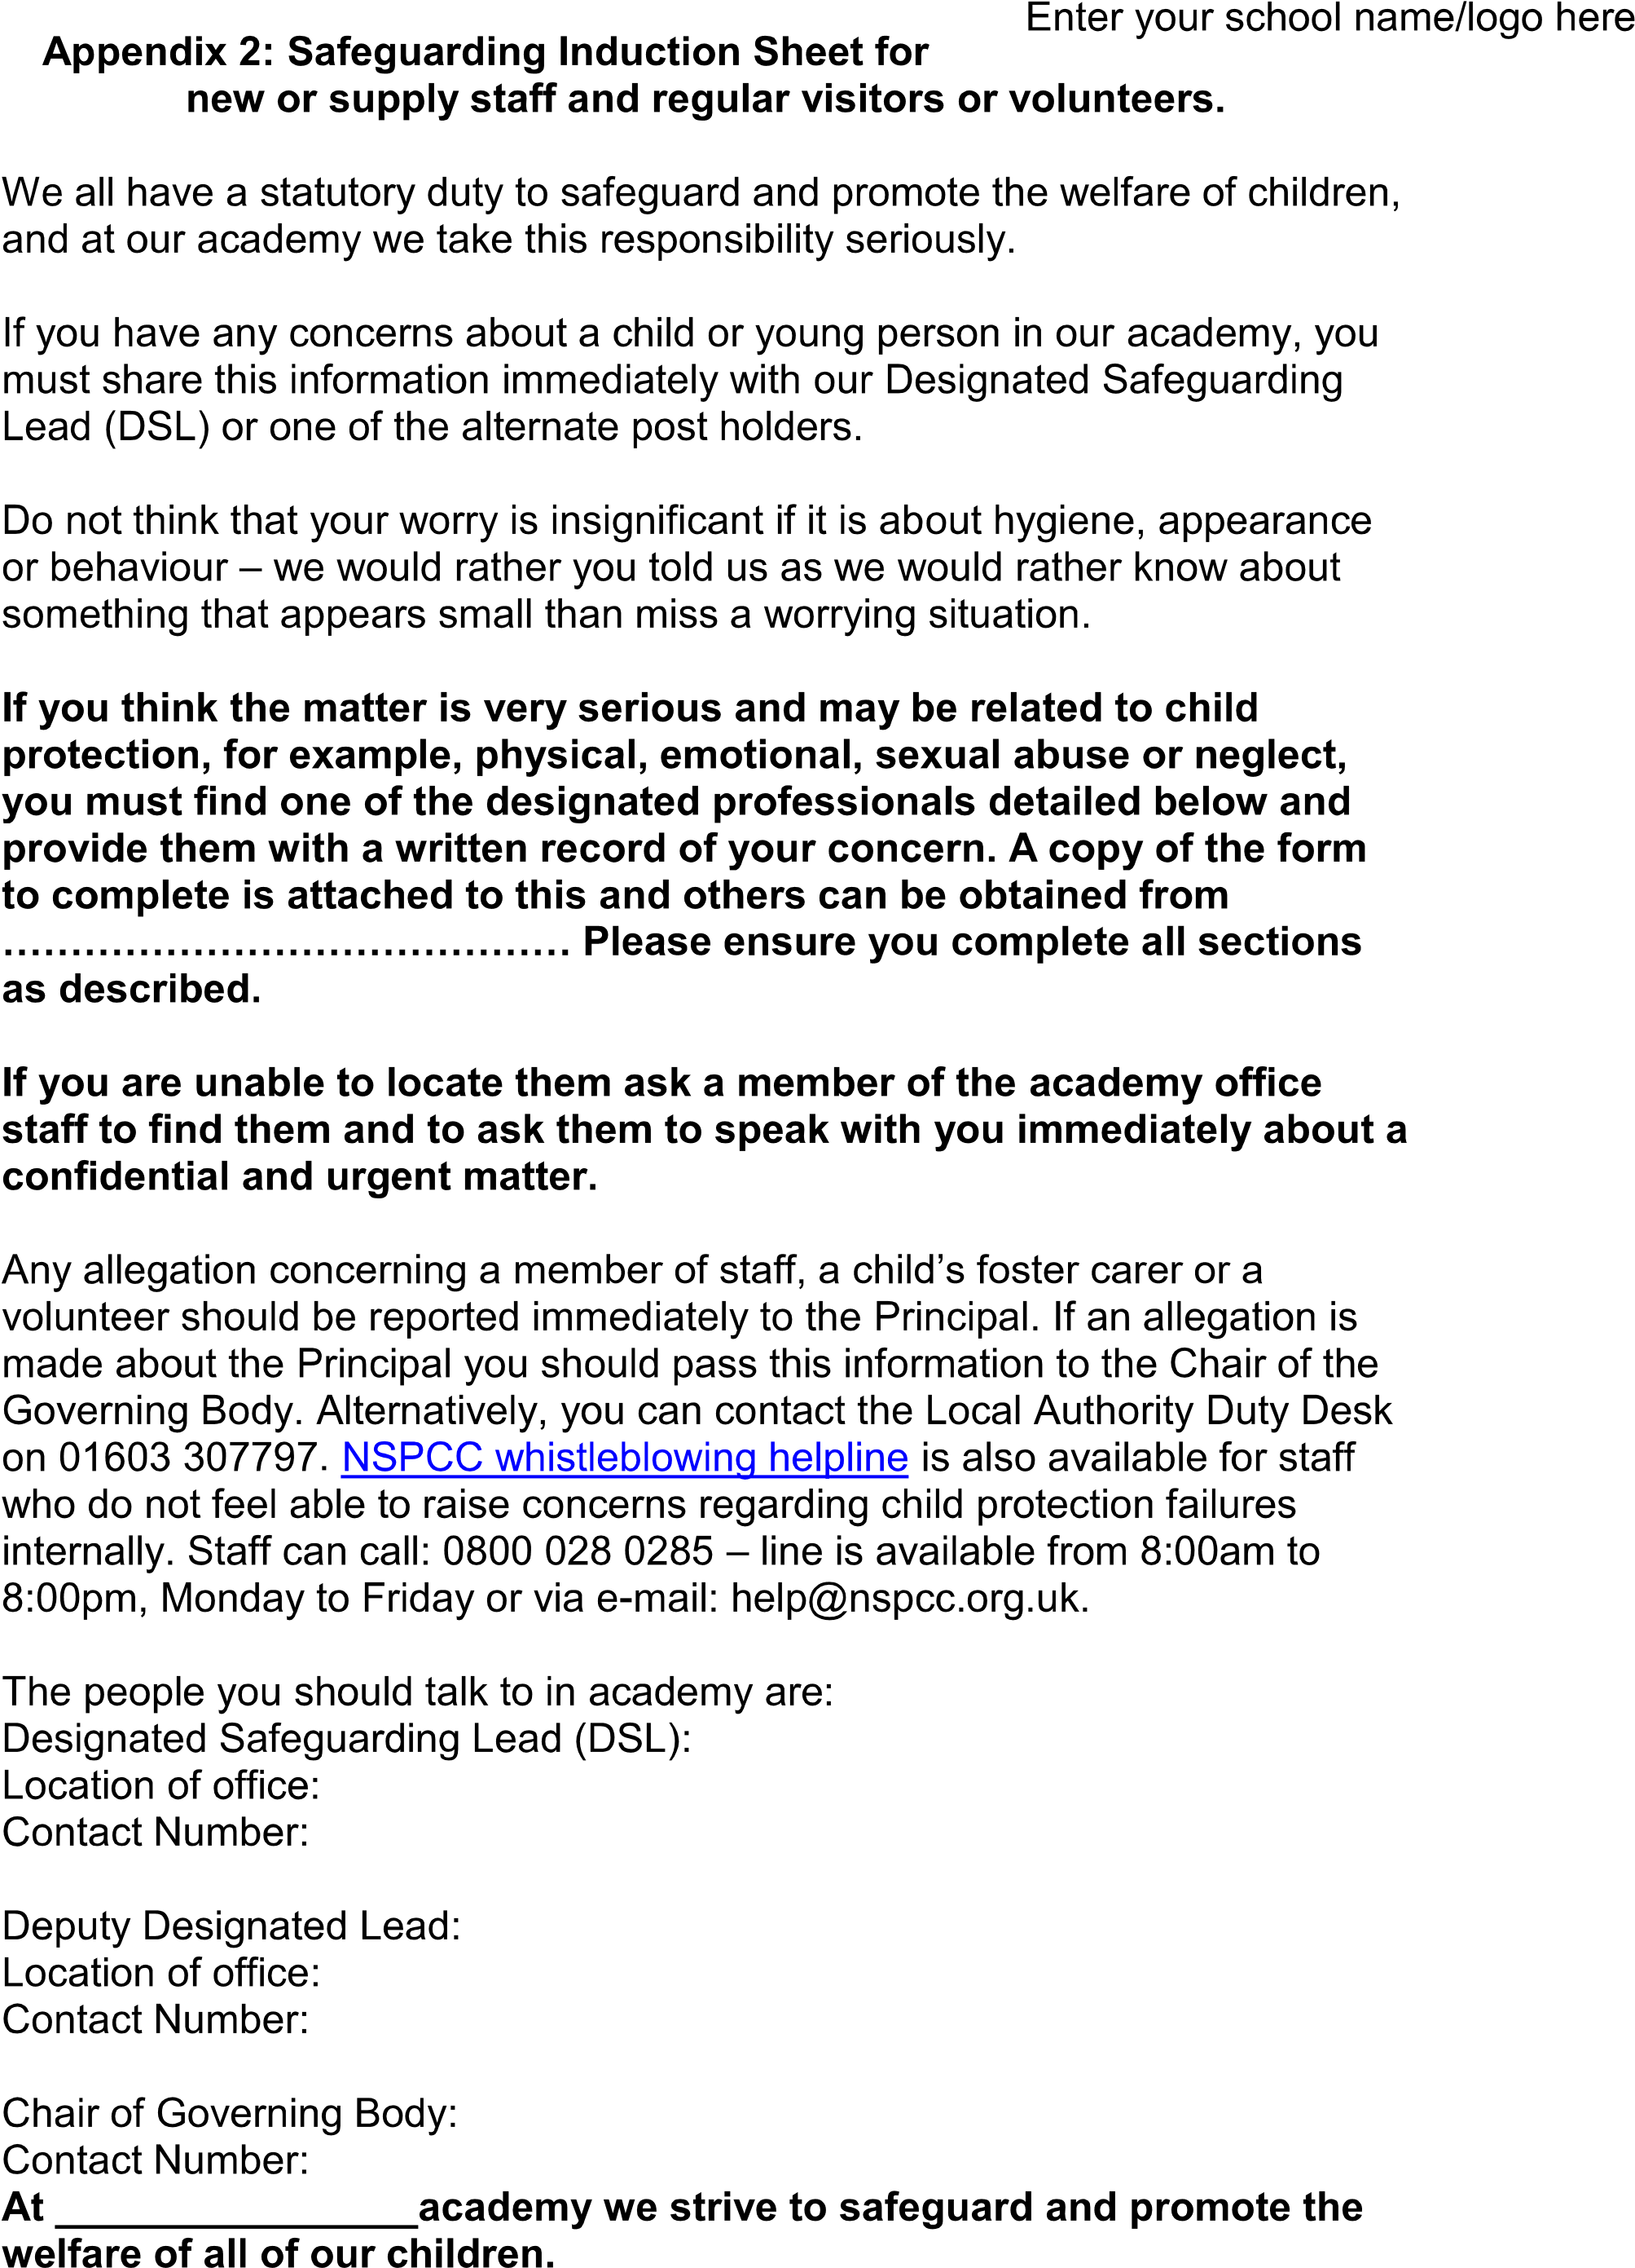

Children’s Advice and Duty Service­ CADS
Where you have carried out an Early Help
Assessment and Plan which has been reviewed and amended as required ­ and the
child's needs are not being met or in fact have increased, gather the information requested
Before contacting CADS, please answer the following questions and follow the advice provided:
Can you evidence that the child is experiencing or
likely to suffer significant harm?
NO
YE
S
Do you have the consent of the parents/young person to make contact with  CADS or have you informed them of your intention to do so? |  | Have you discussed the child's needs with your agency safeguarding lead or your line manager?
Inform the parents and/or gain their consent for you to make this  contact unless doing so would put  the child at risk | Discuss the child with your agency safeguarding lead or line manager if available and follow their advice when providing support to the  family
Gather all the family’s details including dates of birth, current address, current and working contact details and family composition, along with the history and current worries.
Have you considered setting up an FSP or
Have you carried out an Early Help assessment and/or Early Help Plan with the child and their family?
Speak to the parents and the child about your worries and discuss with
Call CADS on the professionals only phone line. This number can be found in the staffroom. Have a discussion with a Consultant Social Worker. A copy of the discussion with be securely emailed or
posted to you. Follow the advice given by the Consultant social worker.
Keep a record for your own agency’s safeguarding recording process
NB: The contact number for parents, carers and members of the public is
0344 800 8020.
them how your agency can help and
support the children and family. You could carry out an FSP, an Early Help Assessment or seek Early Help support. Follow the Early Help
guidance on the NSCB website to support you in this process.
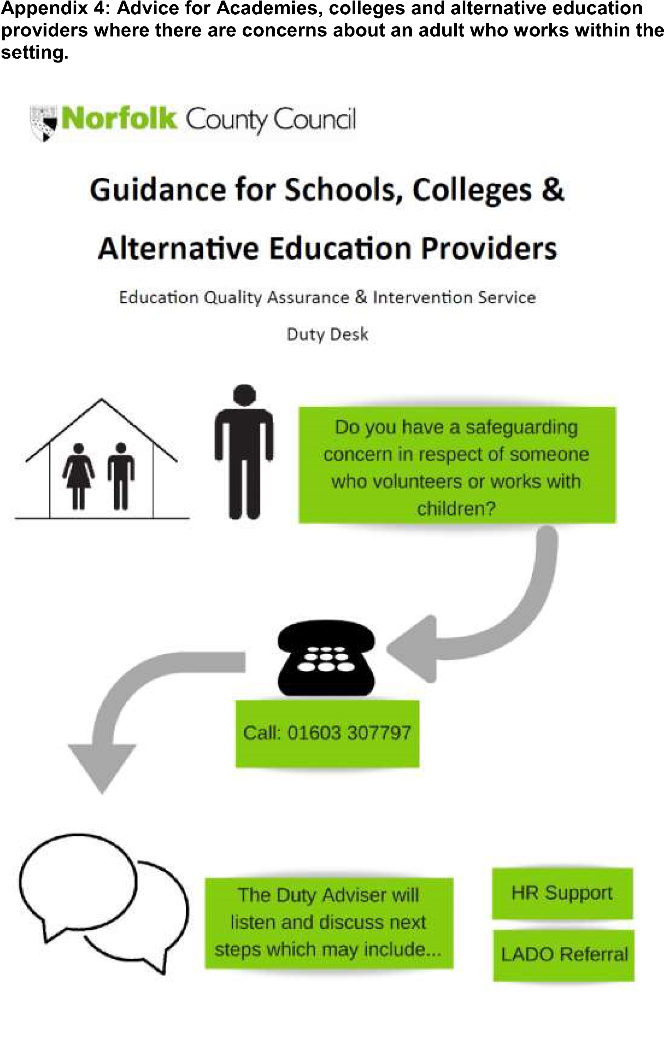
Policy for Safeguarding incorporating Child Protection Annex A
Academy – specific information 2019-2020
To be completed and published on individual academy

Websites: For Eastgate Academy click on the following link https://eastgateacademy.co.uk

For Annexe A click on link below
https://eastgateacademy.co.uk/wp-content/uploads/2019/11/Annexe-A.pdf

