Policy  Author  Approved by  Date of Approval  Review Date | Annex A Eastgate Academy Safeguarding Procedures  Kerensa Healy  Designated Safeguarding Lead  Academy Council  September 2026  September 2027

ANNEX A – EASTGATE ACADEMY LOCAL SAFEGUARDING PROCEDURES

As a member of the Eastern Multi Academy Trust we are committed to our shared ethos on the safeguarding of young people.

The child’s welfare is of paramount importance. We will establish and maintain an ethos where pupils feel secure, are encouraged to talk, are listened to and are safe. Children at our academies will be able to talk freely to any member of staff if they are worried or concerned about something.

Our Curriculum

At Eastgate Academy our curriculum is used to promote safeguarding pupils by teaching pupils how to stay safe and to protect themselves from harm. Our children are taught about the role of safeguarding and how to take responsibility for their own and others safety in and out of Academy.

Restorative approaches are followed at Eastgate Academy. The four key features are Respect, Responsibility, Repair and Re-integrations. We teach children about feelings and behaviour through our RSHE curriculum. Further to this, the Academy teaches online safety throughout the year including involvement with external agencies such as NSPCC. We also provide taught sessions about Sex and Relationships.
Furthermore, our computing curriculum teaches our pupils about Digital Literacy. They learn about the impact of technology on our lives and society; how to be competent, safe and an efficient user, during their autumn term E-safety units. During the spring term, our pupils will participate in the National Safer Internet Day themes to further develop their understanding of how to behave online, how to identify risks and how and when to seek support.
Alongside standalone pieces of work and messages delivered through other curriculum areas and whole Academy assemblies/workshops, children will be provided with age-appropriate skills, knowledge and understanding to help them recognise and respond to issues such as consent and healthy relationships. Children will also learn about the wider safeguarding curriculum, which includes road safety, anti-bullying and knowing how to seek support when needed. The Academy will ensure the curriculum promotes an understanding of the values needed to live within a democratic society including the rule of law and individual liberty.
Educational visits will always have thorough risk assessments undertaken which are shared with adults and children.

Staff and Volunteers

To ensure staff are fully up to date in regards to safeguarding pupils there is annual in house training led by a designated safeguarding lead to make clear roles and responsibilities as part of Keeping Children Safe in Education 2026 (KCSIE 2026).
In addition, staff are regularly updated with key information through staff meetings, emails (including e-courier and pupil awareness memos as appropriate), and EMAT / Academy safeguarding newsletters. Staff members are also provided with the following documents, which they must read and sign for annually:
- Part One of Keeping Children Safe in Education
- EMAT Policy for Safeguarding Incorporating Child Protection
- Eastgate Academy Behaviour Policy
- Eastgate Academy Staff Code of Conduct
- Eastgate Academy Anti-Bullying Policy
Filtering and Monitoring
The Department for Education’s statutory guidance ‘Keeping Children Safe in Education’ obliges Academies and colleges in England to “ensure appropriate filters and appropriate monitoring systems are in place. Children should not be able to access harmful or inappropriate material from the Academy system however, Academies will need to be careful that over blocking does not lead to unreasonable restrictions as to what children can be taught with regards to online teaching and safeguarding. It is important to recognise that no filtering systems can be 100% effective and need to be supported with good teaching and learning practice and effective supervision.
Our Filtering and Monitoring is provided by Turn It On – our current IT support and providers. They are responsible for setting up the initial filtering and monitoring to enable Eastgate Academy to function safely online with all pupils, whilst not over-restricting usage, so that parts of the curriculum become inaccessible.
We recognise that technology, and risks and harms related to the internet evolve and change rapidly. We also communicate with parents and carers to reinforce the importance of children being safe online.
DSL responsible for filtering and monitoring the IT system at Eastgate Academy:
Kerensa Healy

Visitors, Temporary Staff and Volunteers

Visitors to the Academy are provided with a safeguarding leaflet, which details actions to take should they have any concerns about a child. Temporary staff and volunteers have a safeguarding induction, covering how to report concerns, signs to be aware of and how to deal with a child’s disclosure prior to starting work at the Academy.
Throughout the Academy, there are safeguarding posters that have photos, names and details of all the DSLs.
Attendance
In the event of a child being absent from Academy there is a clear policy to follow – our attendance policy can be found on the academy website. If a child has not come into Academy and there has been no information from parents/carers then a member of office staff will call parents/carers to ascertain the reason for absence. If the first contact person is unavailable then the second or third contact will be telephoned.

Should the Academy become concerned about a child’s absence, a member of the DSL team will conduct a home visit. Attendance of all children is reviewed regularly and where it is a cause for concern parents/careers will be expected to attend an attendance improvement meeting.

The Academy has a robust policy to reduce the possibility of a child going missing in education. Where we are advised that a child is transferring to a new Academy contact is made with that Academy to ensure the child has attended for their first day.

Appropriate Children Missing in Education forms are completed for all children who leave the Academy and are forwarded to the local authority.

Safeguarding Referrals

Should any adult have a safeguarding concern within the Academy, they are asked to follow these reporting procedures:

- Any safeguarding concern should be reported to a DSL as soon as possible and recorded on the Academy’s safeguarding system – CPOMS – and assigned to the safeguarding team.
- Visitors, temporary staff and volunteers who do not have a login for CPOMS, must inform a DSL immediately using Appendix 1: Draft Recording Form for Safeguarding Concerns for Visitors to the academy.
- Appendix 1: Draft Recording Form for Safeguarding Concerns for Visitors to the academy are located in the office, in the staff room and on the academy website.
- The next steps of follow up will be lead by the DSLs, which may include pupil and parent meetings or information gathering activities such as Wishes and Feelings.
- DSLs will then use the Local Authorities Continuum of Needs Guidance to determine what level of action is required, most notably whether the external advice from Children’s Advice and Duty Service (CADS) is sought.
- In this case, such contact can only be made without parental consent if there is sufficient evidence to feel that a child will be harmed by waiting or through seeking this permission.
- In addition, any member of staff or member of the public can make a referral to children’s services on 0344 800 8020 if they feel that a child is at risk of immediate serious harm outside of normal Academy hours.

The Academy Safeguarding Team meets frequently to discuss safeguarding throughout the Academy. The Safeguarding Team remains in constant contact via CPOMS which links them all directly to concerns raised, actions and outcomes.

The Academy works with external agencies. Details can be found in Appendix 4.

Operation Encompass

The Academy is part of a jointly run operation between Norfolk County Council, Norfolk Police and our Academy which is called Operation Encompass. Operation Encompass has been set up to help schools to provide support to children who have been present at incidents of domestic violence. We know that children can be significantly physically and emotionally harmed when they are involved in, present or witness to domestic violence.

The lead for Operation Encompass at Eastgate Academy is Kerensa Healy (DSL).

During term time the designated safeguarding lead (or an alternate DSL) will always be available (during Academy hours) for staff in the Academy to discuss any safeguarding concerns.
Out of hours designated safeguarding leads are Kerensa Healy and Andrew Stratton who can be contacted on their Academy email.
Roles and Responsibilities

Role | Name | Contact Details
Designated Safeguarding Lead | Kerensa Healy  (Monday to Thursday)  Andrew Stratton  (Friday) | 01553 773088  Kerensa.healy@ega.eastern-mat.co.uk  andrew.stratton@ega.eastern-mat.co.uk
Deputy Designated Safeguarding Lead | Ewa Parker  Carole Walker  Ellen Stratton  Justina Snow | ewa.parker@ega.eastern-mat.co.uk  carole.walker@ega.eastern-mat.co.uk  ellen.stratton@ega.eastern-mat.co.uk  justina.snow@ega.eastern-mat.co.uk
Named person for Filtering and Monitoring the IT system | Kerensa Healy | Kerensa.healy@ega.eastern-mat.co.uk
Principal | Ewa Parker | ewa.parker@ega.eastern-mat.co.uk
Assistant Principals | Jackie Rutter  Kerensa Healy | Jackie.rutter@ege.eastern-mat.co.uk  kerensa.healy@ega.eastern-mat.co.uk
Named Safeguarding Governor |  | c/o Eastgate Academy 01553 773088
Chair of Local Governing Body |  | c/o Eastgate Academy 01553  773088
Safer Recruitment trained personnel | Ewa Parker  Elaine Oldroyd  Jackie Rutter  Andrew Stratton | 01553 773088

Mental Health

A key area within safeguarding is the health and wellbeing of our pupils. We have a number of members of staff that have taken on the role of Mental Health Lead and Mental Health first aider.

Senior Mental Health Lead: Kerensa Healy

Mental Health Champions: Leanne Collison

In addition, the academy works with the King’s Lynn Mental Health Support Team, who allow the Academy to refer families onto their service where necessary. They provide workshops, transition activities and parental support regarding children’s mental health.

Further information is on the Academy website.

Visits

All visits to external venues and activities involving external agencies undertaken on Academy premises will have thorough risk assessments undertaken and shared with adults and children involved in these activities. Risk assessments will also be logged using the Norfolk County Council Evolve portal.

Operation Encompass

The Academy is part of a jointly run operation between Norfolk County Council, Norfolk Police and our Academy, which is called Operation Encompass. Operation Encompass has been set up to help schools to provide support to children who have been present at incidents of domestic violence. We know that children can be significantly physically and emotionally harmed when they are involved in, present or witness to domestic violence.

Appendix 1: Draft Recording Form for Safeguarding Concerns for Visitors to the academy

Staff, volunteers and regular visitors are required to complete this form and pass it to one of the DSLs (Kerensa Healy, Ewa Parker, Andrew Stratton, Ellen Stratton, Justina Snow or Carole Walker) if they have a safeguarding concern about a child in our Academy if they do not have access to the online CPOMS system

Full name of child | Date of Birth | Class/Tutor/Form group | Your name and position in Academy

Nature of concern/disclosure
Please include where you were when the child made a disclosure, what you saw, who else was there, what did the child say or do and what you said.

Time & date of incident:

Who are you passing this information to?
Name:

Position:

[Ensure that if there is an injury this is recorded (size and shape) and a body map is completed]
[Make it clear if you have a raised a concern about a similar issue previously]

Your signature:

Time form completed:
Date:

Time form received by DSL:

Action taken by DSL:

Referred to…?

Attendance Police Just One CADS FLO Community & Other
Lead Norfolk Partnerships

Date: Time:

Parents informed? Yes / No (If No, state reason)

Feedback given to…?

SLT Teacher Child Person who recorded disclosure

Further Action Agreed:
e.g. School to instigate an Early Help Assessment Plan, assessment by Children’s Services

Full name:
DSL Signature:
Date:

Body Map

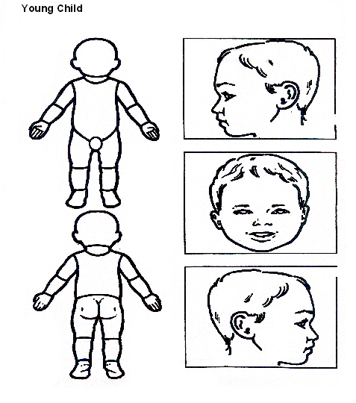

Indicate clearly where the injury was seen and attach this to the Recording Form

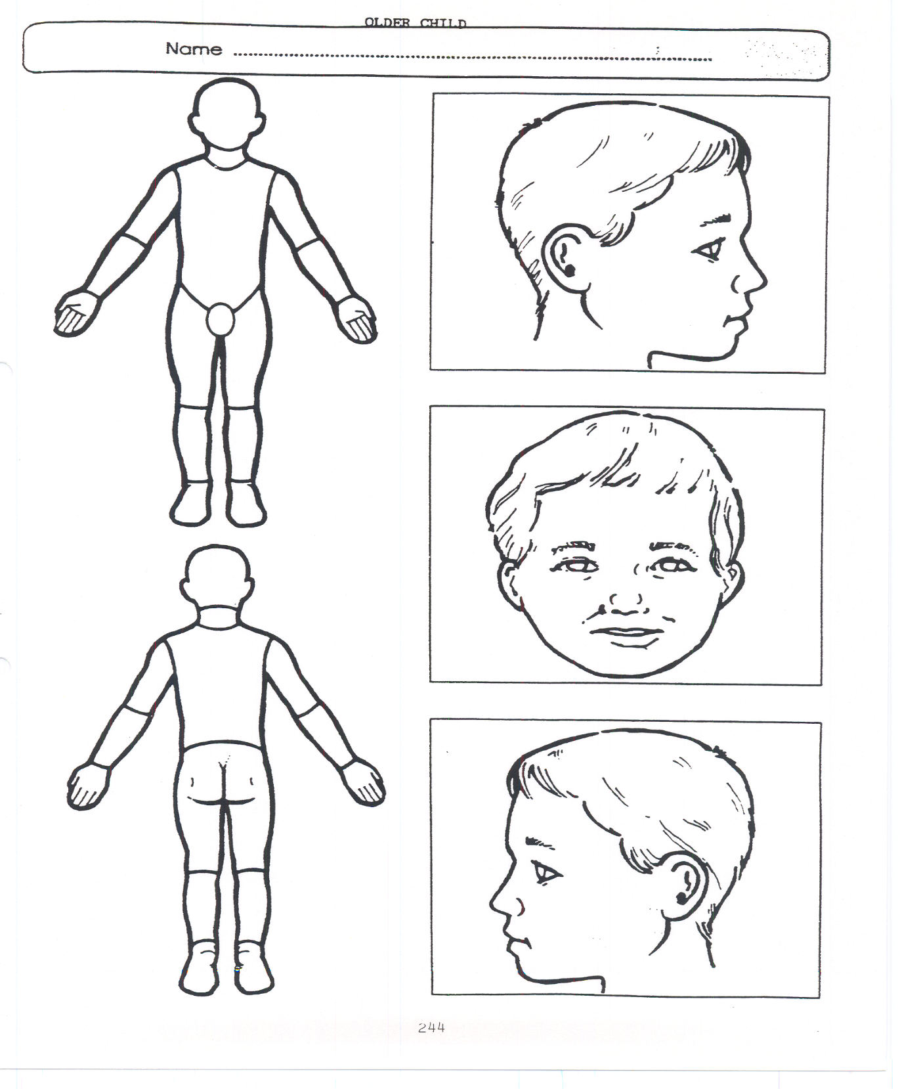
Older Child

Indicate clearly where the injury was seen and attach this to the Recording Form

Appendix 2: Safeguarding Induction Sheet for new or supply staff and regular visitors or volunteers.

We all have a statutory duty to safeguard and promote the welfare of children, and at our academy we take this responsibility seriously.
If you have any concerns about a child or young person in our academy, you must share this information immediately with our Designated Safeguarding Lead (DSL) or one of the alternate post holders.
Do not think that your worry is insignificant if it is about hygiene, appearance or behaviour – we would rather you told us as we would rather know about something that appears small than miss a worrying situation.
If you think the matter is very serious and may be related to child protection, for example, physical, emotional, sexual abuse or neglect, you must find one of the designated professionals detailed below and provide them with a written record of your concern. A copy of the form to complete is attached to this and others can be obtained from the school office.
Please ensure you complete all sections as described.
If you are unable to locate them ask a member of the academy office staff to find them and to ask them to speak with you immediately about a confidential and urgent matter.
Any allegation or low-level concern about a member of staff, a child’s foster carer or a volunteer should be reported immediately to the Principal. If an allegation is made about the Principal you should pass this information to the Chair of the Governing Board. Alternatively, you can contact the Local Authority Duty Desk on 01603 307797. NSPCC whistleblowing helpline is also available for staff who do not feel able to raise concerns regarding child protection failures internally. Staff can call: 0800 028 0285 – the line is available from 8:00am to 8:00pm, Monday to Friday or via e-mail: help@nspcc.org.uk.
The people you should talk to in academy are:
Designated Safeguarding Lead (DSL): Kerensa Healy (Monday to Thursday)
Andrew Stratton (Friday)
Location of office: Infant corridor
Contact Number: 01553 773088

Deputy Designated Lead: Ewa Parker
Location of office: Principal Office
Contact Number: 01553 773088

Chair of Governing Board:
Contact Number:

At Eastgate Academy we strive to safeguard and promote the welfare of all our children.

Appendix 3: Local Safeguarding Procedures Children’s Advice and Duty Service- CADS

Appendix 3: Children’s Advice and Duty Service
Safeguarding process:
1. Identify & Assess Risk: Identify child at potential or actual risk.
2. Consult DSL: Report concerns to your organisation's Designated Safeguarding Lead and document them (e.g., CPOMS) and follow advice regarding contacting CADS or completing a Request for Support.’
3. Immediate Protection: If the child is in immediate danger, call 999.
4. Contact CADS if child protection or immediate safeguarding
concerns.
5. Professionals call 0344 800 8021 and choose from the following
options:
Press 1 – if the child or young person is currently being supported by a Social Worker or Family Practitioner.
Press 2 – if your call relates to Child Exploitation.
Press 3 – if your call relates to Domestic Abuse.
Press 0 – for Child Protection and immediate safeguarding concerns.
(If the lines are busy and your call is not answered within 40 minutes, a call back option will be offered).
To use the service, members of the public can call the Customer Service Centre number 0344 800 8020.
6. Request Support for Universal, Community based Early Help and Family Help Complete a Request for Support form:
Targeted early help and community-based support can be accessed via Request for support - Norfolk County Council. Early Help is designed to support children, young people, and families experiencing difficulties that may affect their wellbeing, development, or ability to flourish.
Consent: Inform parents/carers of the concerns and gain consent for support from Early Help services, prior to a call or completing a Request for Support unless doing so places the child at further risk.

Universal services and community-based early help
Universal outcomes and community based early help provide preventative support for children and families of all ages, strengthening resilience, improving outcomes, and reducing the risk of needs escalating. Delivered as a coordinated local system rather than a single service, this support is offered through universal provision such as education, health, and wider community services.
It includes services like Best Start Family Hubs, youth, and housing support, and after academy provision.
Best Start Family Hubs offer a clear pathway from pregnancy to age 19 (or 25 for young people with SEND), bringing together multi agency partners to provide accessible, ongoing community support and to safeguard families, including those transferring from targeted or specialist services.
Family Help – targeted early help, safeguarding, and promoting the welfare of children.
Family Help is offered where universal services and community based early help have not achieved sufficient or sustained improvement, or where a child and family present with multiple, complex, or escalating needs. Delivered through a coordinated, multi-agency approach led by Children’s Services and its partners, Family Help provides structured support to address identified risks and concerns. Family Help will only be initiated where there is an agreed Family Plan, or a Graded Care Profile (GCP) in cases of neglect, which has been shared with CADS.
Family Help is a voluntary, consent based approach that supports families to build capacity, improve outcomes, and reduce risks, including families in kinship arrangements and those requiring additional support during pregnancy, with the aim of preventing the need for statutory child protection intervention.
Consent: Inform parents/carers of the concerns and gain consent for support from Early Help services, prior to a call or completing a Request for Support unless doing so places the child at further risk.
7. CADS: A member of the team responds to the call or Request for Support and decides on next steps.
8. Information Gathering: MASH partners (police, health, social care) share information if required.
9. Outcome & Action:
Information, advice, and guidance
Community based Early Help
Family Help
10. Feedback: Following a call CADS provides feedback to the referrer regarding the outcome.

Appendix 4: Advice for schools, colleges and alternative education providers where there are concerns about an adult who works within the setting

Appendix 5:
Access Supporting migrants
ACCESS exists to help migrants settle into their local communities.
https://www.accessmigrantsupport.org.uk/
Telephone: 01553 773905
Early Help
If you have difficulties in your family or are worried about your children, there are people who can offer help and support.
Early Help is for children of any age (0-17) and their family. It’s about getting information, advice and guidance to prevent family worries escalating into bigger issues.
https://www.norfolk.gov.uk/children-and-families/early-help-and-family-support
Hanseatic Union
The Hanseatic Union was set up ten years ago to help the community in King’s Lynn and West Norfolk to find the support they need – even if English isn’t their first language.
https://www.hanseaticunion.co.uk/
Just One Norfolk
Call Just One Number or text Parentline with any questions or concerns about your child's health, wellbeing or development.
https://www.justonenorfolk.nhs.uk/
Just One Number 0300 300 0123
Parentline 07520 631590
Matthew Project
Empowering people to overcome issues with drugs, alcohol, and mental health
Providing support within the East of England
Drug and alcohol recovery | The Matthew Project | England
01603 626123
hello@matthewproject.org

Nelsons Journey
Nelson's Journey supports children and young people in Norfolk who've experienced the death of a significant person.
https://nelsonsjourney.org.uk/
General enquiries: enquiries@nelsonsjourney.org.uk
Telephone: 01603 431788
Ormiston Families
Working across the East of England, Ormiston Families support children, young people and their families to see a brighter future.
https://www.ormiston.org/
Telephone: 01473 724517
enquiries@ormistonfamilies.org.uk
Pandora Project
Pandora Project is a West Norfolk based domestic abuse charity, passionate about making a difference. A dedicated and specialist team offering advice, support and information to women and children affected by domestic abuse.
https://www.pandoraproject.org.uk/
STEAM House Cafe – King's Lynn
Steam House Cafes are a safe space to seek mental health and wellbeing support.
https://www.facebook.com/steamhousekl/
https://steamhousecafes.co.uk/kings-lynn/
Telephone: 07388 377827
steamkl@accessct.org
Trussell Trust - King’s Lynn Foodbank
TS Vancouver Building, St Margaret's Lane, King's Lynn, PE30 5DS
Telephone: 07582 558143
http://kingslynn.foodbank.org.uk
info@kingslynn.foodbank.org.uk

Other Useful Sites

The NSPCC – offering support and advice if you have concerns about a child
www.nspcc.org.uk/

Talk PANTS – toolkit and information for parents on teaching children how to keep safe. We use this in Academy.
www.nspcc.org.uk/preventing-abuse/keeping-children-safe/underwear-rule/

The NSPCC has created a video in British Sign Language with subtitles and aim to teach deaf children about the Underwear Rule and encourages them to share secrets that upset them with a trusted adult.

You can find the video here:
https://youtu.be/lvD74L86Mr8

Norfolk Safeguarding Children Partnership
www.norfolklscb.org

