Policy  Author  Approved by  Date of Approval  Review Date | Annex A Eastgate Academy Safeguarding Procedures  Kerensa Healy  Designated Safeguarding Lead  Academy Council  September 2025  September 2026

ANNEX A – EASTGATE ACADEMY LOCAL SAFEGUARDING PROCEDURES

As a member of the Eastern Multi Academy Trust we are committed to our shared ethos on the safeguarding of young people.

The child’s welfare is of paramount importance. We will establish and maintain an ethos where pupils feel secure, are encouraged to talk, are listened to and are safe. Children at our academies will be able to talk freely to any member of staff if they are worried or concerned about something.

Our Curriculum

At Eastgate Academy our curriculum is used to promote safeguarding pupils by teaching pupils how to stay safe and to protect themselves from harm. Our children are taught about the role of safeguarding and how to take responsibility for their own and others safety in and out of school.

Restorative approaches are followed at Eastgate Academy. The four key features are Respect, Responsibility, Repair and Re-integrations. We teach children about feelings and behaviour through our RSHE curriculum. Further to this, the school teaches online safety throughout the year including involvement with external agencies such as NSPCC. We also provide taught sessions about Sex and Relationships.
Furthermore, our computing curriculum teaches our pupils about Digital Literacy. They learn about the impact of technology on our lives and society; how to be competent, safe and an efficient user, during their autumn term E-safety units. During the spring term, our pupils will participate in the National Safer Internet Day themes to further develop their understanding of how to behave online, how to identify risks and how and when to seek support.
Alongside standalone pieces of work and messages delivered through other curriculum areas and whole school assemblies/workshops, children will be provided with age-appropriate skills, knowledge and understanding to help them recognise and respond to issues such as consent and healthy relationships. Children will also learn about the wider safeguarding curriculum, which includes road safety, anti-bullying and knowing how to seek support when needed. The school will ensure the curriculum promotes an understanding of the values needed to live within a democratic society including the rule of law and individual liberty.
Educational visits will always have thorough risk assessments undertaken which are shared with adults and children.

Staff and Volunteers

To ensure staff are fully up to date in regards to safeguarding pupils there is annual in house training led by a designated safeguarding lead to make clear roles and responsibilities as part of Keeping Children Safe in Education 2025 (KCSIE 2025).
In addition, staff are regularly updated with key information through staff meetings, emails (including e-courier and pupil awareness memos as appropriate), and EMAT / school safeguarding newsletters. Staff members are also provided with the following documents, which they must read and sign for annually:
- Part One of Keeping Children Safe in Education
- EMAT Policy for Safeguarding Incorporating Child Protection
- Eastgate Academy Behaviour Policy
- Eastgate Academy Staff Code of Conduct
- Eastgate Academy Anti-Bullying Policy
Filtering and Monitoring
The Department for Education’s statutory guidance ‘Keeping Children Safe in Education’ obliges schools and colleges in England to “ensure appropriate filters and appropriate monitoring systems are in place. Children should not be able to access harmful or inappropriate material from the school or college’s IT system however, schools will need to be careful that over blocking does not lead to unreasonable restrictions as to what children can be taught with regards to online teaching and safeguarding.” Whilst internet filtering has always been provided by schools, it is the ‘strengthened measures’ that are now a key part of Ofsted online safety during inspections. It is important to recognise that no filtering systems can be 100% effective and need to be supported with good teaching and learning practice and effective supervision.

DSL responsible for filtering and monitoring the IT system at Eastgate Academy: Andrew Stratton

Visitors, Temporary Staff and Volunteers

Visitors to the academy are provided with a safeguarding leaflet, which details actions to take should they have any concerns about a child. Temporary staff and volunteers have a safeguarding induction, covering how to report concerns, signs to be aware of and how to deal with a child’s disclosure prior to starting work at the academy.
Throughout the academy, there are safeguarding posters that have photos, names and details of all the DSLs.

Attendance
In the event of a child being absent from school there is a clear policy to follow – our attendance policy can be found on the academy website. If a child has not come into school and there has been no information from parents/carers then the Attendance Officer who is also a DSL or a member of office staff will call parents/carers to ascertain the reason for absence. If the first contact person is unavailable then the second or third contact will be telephoned.

Should the Academy become concerned about a child’s absence the Academy Attendance Officer will conduct a home visit with a member of the DSL team and then identify further actions if needed. Attendance of all children is reviewed regularly and where it is a cause for concern parents/careers will be expected to attend an attendance improvement meeting with a member of the DSL team and the pupils class teacher.

The Academy has a robust policy to reduce the possibility of a child going missing in education. Where we are advised that a child is transferring to a new school contact is made with that school to ensure the child has attended for their first day.

Appropriate Children Missing in Education forms are completed for all children who leave the school and are forwarded to the local authority.

Safeguarding Referrals

Should any adult have a safeguarding concern within the school, they are asked to follow these reporting procedures:

- Any safeguarding concern should be reported to a DSL as soon as possible and recorded on the school’s safeguarding system – CPOMS – and assigned to the safeguarding team.
- Visitors, temporary staff and volunteers who do not have a login for CPOMS, must inform a DSL immediately using Appendix 1: Draft Recording Form for Safeguarding Concerns for Visitors to the academy.
- Appendix 1: Draft Recording Form for Safeguarding Concerns for Visitors to the academy are located in the office, in the staff room and on the academy website.
- The next steps of follow up will be lead by the DSLs, which may include pupil and parent meetings or information gathering activities such as Wishes and Feelings.
- DSLs will then use the Local Authorities Continuum of Needs Guidance to determine what level of action is required, most notably whether the external advice from Children’s Advice and Duty Service (CADS) is sought.
- In this case, such contact can only be made without parental consent if there is sufficient evidence to feel that a child will be harmed by waiting or through seeking this permission.
- In addition, any member of staff or member of the public can make a referral to children’s services on 0344 800 8020 if they feel that a child is at risk of immediate serious harm outside of normal school hours.

The Academy Safeguarding Team meets half termly to discuss safeguarding throughout the Academy. The Safeguarding Team remains in constant contact via CPOMS which links them all directly to concerns raised, actions and outcomes.

The Academy works with a number of external agencies. Details can be found in Appendix 4.

Operation Encompass

The Academy is part of a jointly run operation between Norfolk County Council, Norfolk Police and our Academy which is called Operation Encompass. Operation Encompass has been set up to help schools to provide support to children who have been present at incidents of domestic violence. We know that children can be significantly physically and emotionally harmed when they are involved in, present or witness to domestic violence.

The lead for Operation Encompass at Eastgate Academy is Andrew Stratton (lead DSL and SENDco).

During term time the designated safeguarding lead (or an alternate DSL) will always be available (during school hours) for staff in the school to discuss any safeguarding concerns.

Out of hours designated safeguarding leads are Andrew Stratton and Ewa Parker who can be contacted on their school email.

Roles and Responsibilities

Role | Name | Contact Details
Designated Safeguarding Lead | Andrew Stratton | 01553 773088  andrew.stratton@ega.eastern-mat.co.uk
Deputy Designated Safeguarding Lead | Ewa Parker  Carole Walker  Ellen Stratton  Justina Snow | 01553 773088  ewa.parker@ega.eastern-mat.co.uk  carole.walker@ega.eastern-mat.co.uk  ellen.stratton@ega.eastern-mat.co.uk  justina.snow@ega.eastern-mat.co.uk
Named person for Filtering and Monitoring the IT system | Andrew Stratton | 01553 773088  Andrew.stratton@ega.eastern-mat.co.uk
Principal | Ewa Parker | 01553 773088  ewa.parker@ega.eastern-mat.co.uk
Assistant Principals | Jackie Rutter  Kerensa Healy | 01553 773088  Jackie.rutter@ege.eastern-mat.co.uk  kerensa.healy@ega.eastern-mat.co.uk
Named Safeguarding Governor | Andy Rogers | c/o Eastgate Academy 01553 773088
Chair of Local Governing Body | Richard Brown | c/o Eastgate Academy 01553  773088
Safer Recruitment trained personnel | Elaine Oldroyd  Jackie Rutter  Andrew Stratton | 01553 773088

Mental Health

A key area within safeguarding is the health and wellbeing of our pupils. We have a number of members of staff that have taken on the role of Mental Health Lead and Mental Health first aider.

Senior Mental Health Lead: Kerensa Healy

Mental Health Champions: Alison Williamson and Leanne Collison

In addition, the academy works with the King’s Lynn Mental Health Support Team, who allow the school to refer families onto their service where necessary. They provide workshops, transition activities and parental support regarding children’s mental health.

Further information is on the school website.

Visits

All visits to external venues and activities involving external agencies undertaken on Academy premises will have thorough risk assessments undertaken and shared with adults and children involved in these activities. Risk assessments will also be logged using the Norfolk County Council Evolve portal.

Operation Encompass

The Academy is part of a jointly run operation between Norfolk County Council, Norfolk Police and our Academy, which is called Operation Encompass. Operation Encompass has been set up to help schools to provide support to children who have been present at incidents of domestic violence. We know that children can be significantly physically and emotionally harmed when they are involved in, present or witness to domestic violence.

Appendix 1: Draft Recording Form for Safeguarding Concerns for Visitors to the academy

Staff, volunteers and regular visitors are required to complete this form and pass it to one of the DSLs (Kerensa Healy, Ewa Parker, Andrew Stratton, Ellen Stratton, or Carole Walker) if they have a safeguarding concern about a child in our school if they do not have access to the online CPOMS system

Full name of child | Date of Birth | Class/Tutor/Form group | Your name and position in school

Nature of concern/disclosure
Please include where you were when the child made a disclosure, what you saw, who else was there, what did the child say or do and what you said.

Time & date of incident:

Who are you passing this information to?
Name:

Position:

[Ensure that if there is an injury this is recorded (size and shape) and a body map is completed]
[Make it clear if you have a raised a concern about a similar issue previously]

Your signature:

Time form completed:
Date:

Time form received by DSL:

Action taken by DSL:

Referred to…?

Attendance Police Just One CADS FLO Community & Other
Lead Norfolk Partnerships

Date: Time:

Parents informed? Yes / No (If No, state reason)

Feedback given to…?

SLT Teacher Child Person who recorded disclosure

Further Action Agreed:
e.g. School to instigate an Early Help Assessment Plan, assessment by Children’s Services

Full name:
DSL Signature:
Date:

Body Map

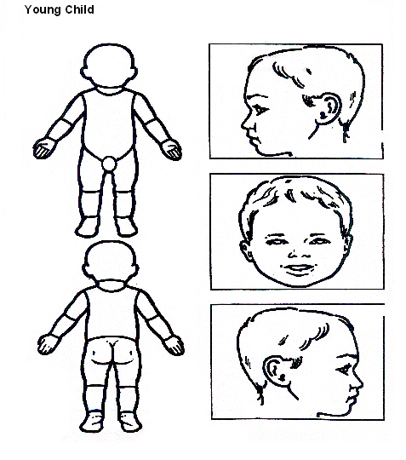

Indicate clearly where the injury was seen and attach this to the Recording Form

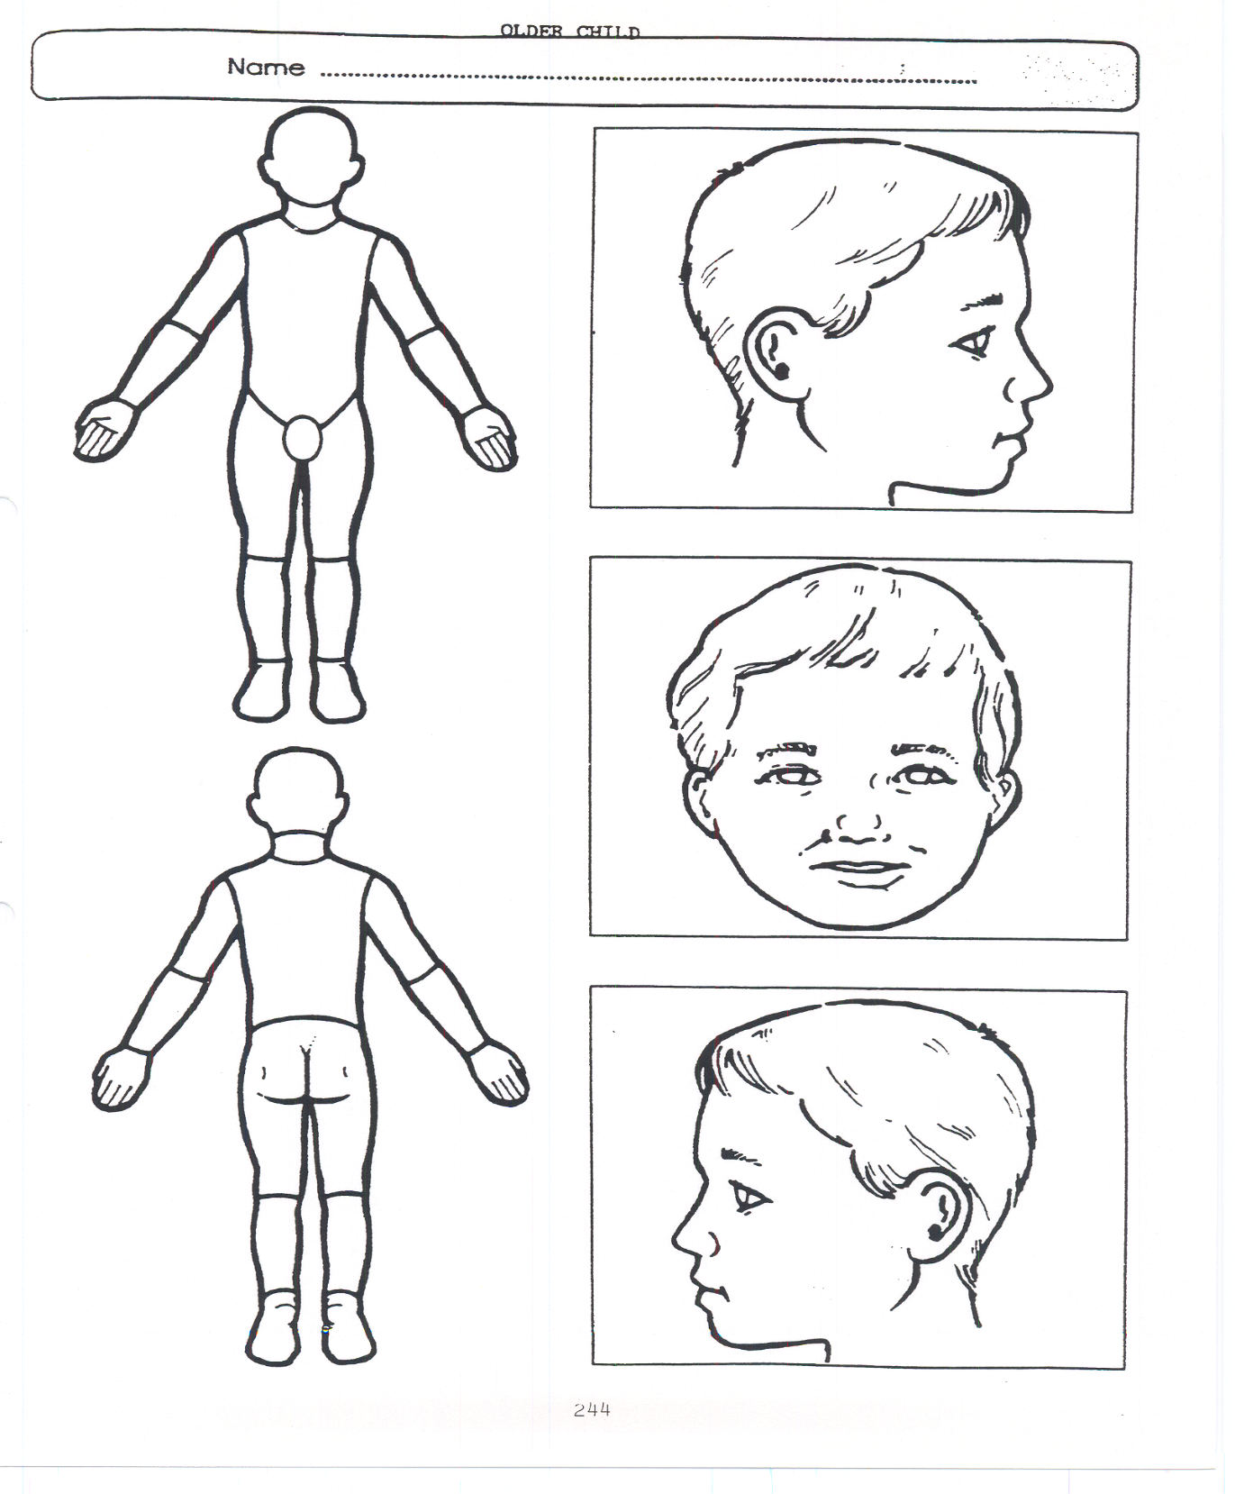
Older Child

Indicate clearly where the injury was seen and attach this to the Recording Form

Appendix 2: Safeguarding Induction Sheet for new or supply staff and regular visitors or volunteers.

We all have a statutory duty to safeguard and promote the welfare of children, and at our academy we take this responsibility seriously.

If you have any concerns about a child or young person in our school, you must share this information immediately with our Designated Safeguarding Lead (DSL) or one of the deputy post holders.

Do not think that your worry is insignificant if it is about hygiene, appearance or behaviour – we would rather you told us as we would rather know about something that appears small than miss a worrying situation.

If you think the matter is very serious and may be related to child protection, for example, physical, emotional, sexual abuse or neglect, you must find one of the designated professionals detailed below and provide them with a written record of your concern. A copy of the form to complete is attached to this and others can be obtained from the school office. Please ensure you complete all sections as described.

If you are unable to locate them ask a member of the school office staff to find them and to ask them to speak with you immediately about a confidential and urgent matter.

Any allegation or low-level concern about a member of staff, a child’s foster carer or a volunteer should be reported immediately to Ewa Parker (Principal) or Andrew Stratton (Lead DSL and SENDco). If an allegation is made about the Principal you should pass this information to the Chair of the Academy Committee.
NSPCC whistleblowing helpline is also available for staff who do not feel able to raise concerns regarding child protection failures internally. Staff can call: 0800 028 0285 – line is available from 8:00am to 8:00pm, Monday to Friday or via e-mail: help@nspcc.org.uk.

The people you should talk to in school are:

Principal: Ewa Parker
Designated Safeguarding Lead (DSL): Andrew Stratton
Contact Number: 01553 773088

Chair of Governing Body: Richard Brown
Contact Number: c/o 01553 773088

At Eastgate Academy we strive to safeguard and promote the welfare of all of our children.

Appendix 3: Local Safeguarding Procedures Children’s Advice and Duty Service- CADS
Before contacting CADS, please answer the following questions and follow the advice provided:
Can you evidence that the child is experiencing or likely to suffer significant harm?

Have you discussed the child's needs with your agency safeguarding lead or your line manager?

NO
YES
Do you have the consent of the parents/young person to make contact with CADS or have you informed them of your intention to do so?

Discuss the child with your agency safeguarding lead or line manager if available and follow their advice when providing support to the family

Inform the parents and/or gain their consent for you to make this contact unless doing so would put the child at immediate risk of harm

Have you carried setting up an Early Help Assessment Plan with the child and their family?

Gather all the family’s details including dates of birth, current address, current and working contact details and family composition, along with the history and current worries.

Speak to the parents and the child about your worries and discuss with them how your agency can help and support the children and family. You could carry out an Early Help Assessment Plan or seek Early Help support. you in this process.
Call CADS on the professionals only phone line. This number can be found in the staffroom. Have a discussion with a Consultant Social Worker. Make a record of the discussion held. Follow the advice given by the Consultant social worker.
Keep a record for your own agency’s safeguarding recording process

NB: The contact number for parents, carers and members of the public is
0344 800 8020.

Where you have carried out an Early Help Assessment Plan which has been reviewed and amended as required - and the child's needs are not being met or in fact have increased, gather the information requested in this form, seek consent from the parent/carers and then contact CADS.

Appendix 4:
Access Supporting migrants
ACCESS exists to help migrants settle into their local communities.
https://www.accessmigrantsupport.org.uk/
Telephone: 01553 773905
Early Help
If you have difficulties in your family or are worried about your children, there are people who can offer help and support.
Early Help is for children of any age (0-17) and their family. It’s about getting information, advice and guidance to prevent family worries escalating into bigger issues.
https://www.norfolk.gov.uk/children-and-families/early-help-and-family-support
Hanseatic Union
The Hanseatic Union was set up ten years ago to help the community in King’s Lynn and West Norfolk to find the support they need – even if English isn’t their first language.
https://www.hanseaticunion.co.uk/
Just One Norfolk
Call Just One Number or text Parentline with any questions or concerns about your child's health, wellbeing or development.
https://www.justonenorfolk.nhs.uk/
Just One Number 0300 300 0123
Parentline 07520 631590
Matthew Project
Empowering people to overcome issues with drugs, alcohol, and mental health
Providing support within the East of England
Drug and alcohol recovery | The Matthew Project | England
01603 626123
hello@matthewproject.org

Nelsons Journey
Nelson's Journey supports children and young people in Norfolk who've experienced the death of a significant person.
https://nelsonsjourney.org.uk/
General enquiries: enquiries@nelsonsjourney.org.uk
Telephone: 01603 431788
Ormiston Families
Working across the East of England, Ormiston Families support children, young people and their families to see a brighter future.
https://www.ormiston.org/
Telephone: 01473 724517
enquiries@ormistonfamilies.org.uk
Pandora Project
Pandora Project is a West Norfolk based domestic abuse charity, passionate about making a difference. A dedicated and specialist team offering advice, support and information to women and children affected by domestic abuse.
https://www.pandoraproject.org.uk/
STEAM House Cafe – King's Lynn
Steam House Cafes are a safe space to seek mental health and wellbeing support.
https://www.facebook.com/steamhousekl/
https://steamhousecafes.co.uk/kings-lynn/
Telephone: 07388 377827
steamkl@accessct.org
Trussell Trust - King’s Lynn Foodbank
TS Vancouver Building, St Margaret's Lane, King's Lynn, PE30 5DS
Telephone: 07582 558143
http://kingslynn.foodbank.org.uk
info@kingslynn.foodbank.org.uk

Other Useful Sites

The NSPCC – offering support and advice if you have concerns about a child
www.nspcc.org.uk/

Talk PANTS – toolkit and information for parents on teaching children how to keep safe. We use this in school.
www.nspcc.org.uk/preventing-abuse/keeping-children-safe/underwear-rule/

The NSPCC has created a video in British Sign Language with subtitles and aim to teach deaf children about the Underwear Rule and encourages them to share secrets that upset them with a trusted adult.

You can find the video here:
https://youtu.be/lvD74L86Mr8

Norfolk Safeguarding Children Partnership
www.norfolklscb.org

