
Eastgate Academy

Newsletter 14

 | - Friday 1st May 2026
Dear Parents and Carers,  As we move closer to the upcoming Key Stage 2 SATs, I would like to remind parents and carers of our Year 6 children to please look out for a separate letter which was sent out earlier today. The letter will contain specific information about arrangements for SATs week and is in addition to the whole-school newsletter.  I would also like to take this opportunity to say how immensely proud we all are of our Year 6 pupils and the dedicated staff who work alongside them. The effort, resilience and determination shown throughout this year has been incredible. It certainly hasn’t always been easy, but the perseverance and commitment demonstrated by everyone has been truly admirable.  Alongside all this hard work, it has been wonderful to see learning coming alive beyond the classroom. Doves and Kingfishers thoroughly enjoyed their recent class trip, where they learned more about life from the Stone Age through to the Iron Age. The children were fully engaged throughout the day, and the experience really helped to deepen their understanding of this important period in history. Our thanks go to the staff at King’s Lynn Museum, who made the learning so vivid and memorable for our children.  As the weather continues to improve and the summer term progresses, we kindly ask parents to ensure children come to school with a named water bottle every day. On sunny days, please also provide a hat and apply sunscreen before school, so that children are able to enjoy their learning and playtimes safely and comfortably.  Thank you, as always, for your continued support. We wish our Year 6 children every success and look forward to celebrating everything they achieve in the weeks ahead.  With warm regards,  Mrs Parker  Principal |  |  | Our Vision  Respect  Yourself, others and our environment.  Pride  In your achievements, community and heritage.  Wellbeing  Make healthy decisions for your mind and body.  Courage  Be brave and learn from your mistakes.  Aspire  Be passionate about your future.  Honesty  Be truthful and accountable to yourself and others.
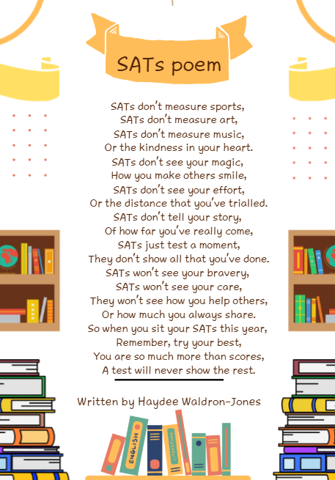

🌟 Eastgate Academy Attendance News Bulletin

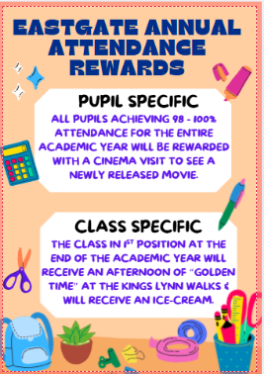
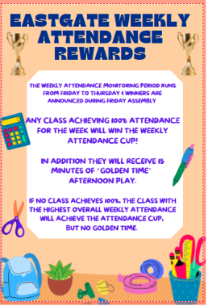
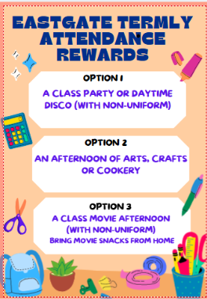

Upcoming Events for the Spring Term - please be advised that dates and events can change

Month | Activity | Information
May
1st | Year 4 trip | Trip to Lynn Museum – email to follow
4th- 10th | Deaf Awareness week | We’re learning sign language throughout the week: Hi! My name is…. ? How are you? Do you need help?
11^{th-} 14th | KS2 SATs | 100% attendance expected
15th | Walkathon | Further communication to follow from Friends of Eastgate (if weather is bad, back up date for Walkathon is 22nd May)
Monday 25th | MAY HALF TERM | Pupils return 1st June
June
4th | September 2026 Open evening for new pupils starting at Eastgate in September.
8th- 12th | Phonics screening test for Y1 pupils  Assessment week
17th | Sandringham Trip | Kingfishers, Penguins and Doves; please look out for letter
19th | Whole School Sports Day | More information to follow. (26th June alternative date for Sports Day).
30th | Whole School Transition Day- Children will find out on the day, who their class teacher and new class will be.
July
Friday 3rd | Pleasurewood trip for Y6 pupils
Monday 6th | School reports sent to parents
Tuesday 14th | Dress Rehearsal for the leaver’s assembly to the rest of school.
Wednesday 15th | Y6 Leaver assembly to parents  There will be two sessions for which you may choose to come. Only two entry tickets per family for a session at 9:15am or 2pm in the main school hall.  This will be bookable via Pupil Asset from 1st July just like parents’ evening now.
Thursday 16th | Majestic Cinema Day for pupils who had 98%- 100% attendance
Thursday 16th | Summer Fair in the afternoon
Friday 17th | School finishes at 3pm for Summer Holidays

